**Effects of spatially heterogeneous lakeside development on nearshore biotic communities in a large, deep, oligotrophic lake (Lake Baikal, Siberia)**

Michael F. Meyer1,8*

Ted Ozersky2

Kara H. Woo3

Kirill Shchapov2

Aaron W. E. Galloway4

Julie B. Schram4

Emma J. Rosi5

Daniel D. Snow6

Maxim A. Timofeyev7

Dmitry Yu. Karnaukhov7

Matthew R. Brousil3

Stephanie E. Hampton3

1. School of the Environment, Washington State University, Pullman, WA, USA

2. Large Lakes Observatory, University of Minnesota - Duluth, Duluth, MN, USA

3. Center for Environmental Research, Education, and Outreach, Washington State University,

Pullman, WA, USA

4. Oregon Institute of Marine Biology, University of Oregon, Charleston, OR, USA

5. Cary Institute of Ecosystem Studies, Millbrook, NY, USA

6. School of Natural Resources, University of Nebraska-Lincoln, Lincoln, NE, USA

7. Biological Research Institute, Irkutsk State University, Irkutsk, Irkutsk Oblast, Russia

8. Current Address: U.S. Geological Survey, Observing Systems Division, Middleton, WI, USA

*corresponding author: michael.f.meyer@wsu.edu

**Running Head:** Baikal littoral food webs

**Keywords**: sewage, PPCP, food webs, fatty acids, human disturbance

**Statement of novelty, significance, and breadth of interest of the science presented in the proposed manuscript**

We examined food web responses to heterogenous disturbance along the shoreline of oligotrophic Lake Baikal. Using sewage-specific indicators (pharmaceuticals and personal care products) we demonstrated that increased nutrients at three discrete lakeside developments (80-1,963 permanent residents) and the associated increased filamentous benthic algal abundance were consistent with sewage pollution. We provide robust evidence that recent increases in filamentous benthic alga are linked to sewage. These changes in benthic algae altered resources and nutrition for grazing invertebrates, whose composition differed along a disturbance gradient. Stable isotope and fatty acid analysis of benthic algae and macroinvertebrates suggested that grazers may compensate for changing resource nutrition through behavior or altered metabolism. This study demonstrates how patchy, low-level eutrophication of oligotrophic systems can cause food web responses.

**Statement indicating why L&O is the best outlet for the work**

This study will appeal to L&O readers interested in both basic and applied issues. From a basic ecology perspective, we investigate how bottom-up disturbances can propagate throughout a food web. From an applied perspective, we highlight how our results can inform monitoring programs. Additionally, we use a suite of interdisciplinary techniques in a manner appreciated by limnologists and oceanographers, such that L&O seems like the perfect home for this manuscript.

**Abstract**

Sewage released from lakeside development can reshape ecological communities. Nearshore periphyton can rapidly assimilate sewage-associated nutrients, leading to increases of filamentous algal abundance, thus altering both food abundance and quality for grazers. In Lake Baikal, a large, ultra-oligotrophic, remote lake in Siberia, filamentous algal abundance has increased near lakeside developments, and localized sewage input is the suspected cause. These shifts are of particular interest in Lake Baikal, where endemic littoral biodiversity is high, lakeside settlements are mostly small, tourism is relatively high (~1.2 million visitors annually), and settlements are separated by large tracts of undisturbed shoreline, enabling investigation of heterogeneity and gradients of disturbance. We surveyed sites along 40 km of Baikal’s southwestern shore for sewage indicators – pharmaceuticals and personal care products (PPCPs) and microplastics – as well as periphyton and macroinvertebrate abundance and indicators of food web structure (stable isotopes and fatty acids). PPCPs, including caffeine and acetaminophen/paracetamol, were spatially related to lakeside development. As predicted, lakeside development was associated with more filamentous algae and lower abundance of sewage-sensitive mollusks. Periphyton and macroinvertebrate stable isotopes and essential fatty acids suggested that food web structure otherwise remained similar across sites; yet, the invariance of amphipod fatty acid composition, relative to periphyton, suggested that grazers adjust behavior or metabolism to compensate for different periphyton assemblages. Our results demonstrate that even low levels of human disturbance can result in spatial heterogeneity of nearshore ecological responses, with potential for changing trophic interactions that propagate through the food web.

**Introduction**

The release of treated and untreated wastewater into aquatic ecosystems is a common human disturbance that can introduce pollutants and reshape aquatic ecological communities (Moore et al. 2003). Nitrogen and phosphorus are among the primary pollutants in wastewater and its associated byproducts (Smith et al. 1999), yet these nutrients can also originate from disparate anthropogenic and natural environmental sources, thereby complicating their use as sewage indicators. For example, agriculture (Powers et al. 2016), watershed processes such as melting permafrost (Tornqvist et al. 2014), and changes in terrestrial plant communities (Moran et al. 2012) can all increase allochthonous nutrient inputs similar to sewage. Regardless of the nutrients’ source, biological processes can further confound sewage detection. Benthic primary producers, especially those in oligotrophic systems (Hampton et al. 2011; Oleksy et al. 2020), can assimilate nutrients quickly from the water column (e.g., hours; Hadwen and Bunn 2005), such that elevated nutrient concentrations may not be not observed.

Because nutrients come from numerous non-sewage sources, indicators consistently associated with sewage loading, such as enhanced δ15N stable isotope signatures (Camilleri and Ozersky 2019), pharmaceuticals and personal care products (PPCPs) (Rosi-Marshall and Royer 2012; Meyer et al. 2019), and microplastics (Barnes et al. 2009), have garnered increasing attention for their usefulness in defining locations of sewage pollution. Stable isotopes, such as δ15N, have been frequently used to trace sewage pollution (Gartner et al. 2002), yet their potential to indicate sewage can be obfuscated by complex terrestrial (e.g., terrestrial oligotrophication; Craine et al. 2018) and aquatic (e.g., variation within and between trophic levels; Guzzo et al. 2011) processes. In contrast to δ15N signatures, PPCPs explicitly originate from human sources (Rosi-Marshall and Royer 2012; Meyer et al. 2019), where PPCP studies from continental (Kolpin et al. 2002) to colloidal pore (Yang et al. 2016) scales, have shown that concentrations tend to be greatest closer to their source. In addition to identifying areas and periods of sewage-specific pollution, PPCPs have also demonstrated robustness in defining gradients of sewage pollution in river systems, with concentrations being directly proportional to population density and inversely proportional to distance from a densely populated area (Bendz et al. 2005). Similar to PPCPs, microplastics (plastic debris up to 5 mm in size) also have been useful to detect sewage pollution (Li et al. 2018) along gradients of increasing human population density (Klein et al. 2015), although they can also originate from non-sewage sources, such as shoreline debris or fishing nets (Moore et al. 2021). In contrast to δ15N signatures and PPCP concentrations, microplastics are typically resistant to degradation (Barnes et al. 2009), providing a signal over a longer time frame than many PPCPs and nutrients in sewage. As a result of each pollutant’s association with sewage, co-located and elevated δ15N, PPCP, and microplastic measurements can be used to infer the spatial extent and timing of sewage pollution in an ecosystem. While microplastics and δ15N may originate from non-sewage sources, instances where PPCPs increase in tandem with either microplastics or δ15N levels can still be reliable indicators of consistent sewage inputs. However, instances where PPCPs are elevated yet microplastics and δ15N measurements do not increase may be inconclusive or suggest transient sewage inputs.

The effects of sewage pollution are frequently first seen in nearshore benthic communities where increased nutrients alter algal species composition, abundance, nutritional quality, as well as food web trophic structure. Increased filamentous algal abundance, for example, has been frequently observed in areas suspected of sewage pollution (Rosenberger et al. 2008; Hampton et al. 2011), likely due to benthic filamentous algae efficiently removing nutrients from the water column (Oleksy et al. 2020). With a changing resource base, grazing macroinvertebrate communities may likewise shift to include more detritivores or species capable of consuming filamentous algae (Rosenberger et al. 2008). In addition to some grazers’ physical difficulty consuming filamentous algae (Mazzella and Russo 1989), there also may be changes in algal nutritional quality, as filamentous algae tend to contain a different mixture of essential fatty acids (EFAs) in comparison to diatoms (Kelly and Scheibling 2012), which dominate periphyton communities in unimpacted ecosystems. In particular, the EFAs 18:3ω3 and 18:2ω6 are commonly associated with green filamentous algae (Taipale et al. 2013), whereas 20:5ω3 is more associated with diatoms (Taipale et al. 2013). All EFAs are largely synthesized by primary producers, and different algal taxonomic groups produce strongly differentiated multivariate signatures (Taipale et al. 2013; Galloway and Winder 2015). Consumers can acquire fatty acids by grazing (Dalsgaard et al. 2003) or upgrading fatty acids at their own energetic expense (Dalsgaard et al. 2003) and often reflect the fatty acid signatures of their diets. Thus, comparing consumer and producer fatty acid compositions can be used to infer how grazing patterns change in response to increasing sewage pollution.

To investigate lake littoral community and food web responses to sewage-associated nutrient pollution, we surveyed 40 km of Lake Baikal’s shoreline for indicators of sewage pollution and metrics of benthic community composition and structure. Located in Siberia, Lake Baikal is the oldest, most voluminous, and deepest freshwater lake in the world (Hampton et al. 2018), with the majority of Lake Baikal’s biodiversity occurring in the littoral zone (Kozhov 1963). While Lake Baikal’s pelagic zone is generally ultra-oligotrophic (O’Donnell et al. 2017), nearshore areas abutting lakeside settlements have shown distinct signs of eutrophication (Timoshkin et al. 2016). Much of Lake Baikal’s shoreline lacks human development, and Baikal’s watershed is largely roadless and unpopulated (Moore et al. 2009). Despite low levels of development, uncharacteristic filamentous algal blooms have been occurring throughout the lake since 2010 (Kravtsova et al. 2014; Timoshkin et al. 2016; Volkova et al. 2018) and even cyanobacterial blooms in 2019 (Bondarenko et al. 2021). While increased *Ulothrix* spp. abundance has historically occurred in Lake Baikal in late summer (Kozhov 1963), recent observations of unprecedented increases in filamentous green algae abundance, especially increases in *Spirogyra* spp. and *Ulothrix* spp. abundance, are thought to be associated with increased nearshore nutrient concentrations (Volkova et al. 2018; Ozersky et al. 2018). Inadequate wastewater management in lakeside settlements is likely the main driver of these nearshore algal blooms (Timoshkin et al. 2016, 2018), motivating further research to identify the extent to which sewage is altering nearshore communities

Given the growing evidence that Baikal’s nearshore periphyton communities are responding to sewage inputs, our goal was to understand how littoral benthic community composition and interactions may be changing near areas of sewage pollution. This overarching goal was divided into three specific objectives:

1. identify areas of wastewater pollution using several complementary sewage indicators,
2. assess the relationship between sewage indicators and littoral periphyton and macroinvertebrate community composition, and
3. evaluate how trophic relationships among littoral benthic community members are impacted by localized sewage pollution.

We hypothesized that (1) sewage indicators, such as PPCP concentrations, δ15N, and microplastic densities, would increase with increasing population density and proximity of lakeside development; (2) an increasing sewage signal would correlate with increased dominance of filamentous benthic algae; and (3) increasing filamentous algal abundance would result in changes in the abundance of different macroinvertebrate feeding guilds, reflected in community composition and dietary tracers such as carbon and nitrogen stable isotopes and fatty acids.

**Methods**

*Site description*

The vast majority of Lake Baikal’s 2,100-km shoreline lacks lakeside development (Moore et al. 2009; Timoshkin et al. 2016). Our study focused on a 40-km section of Baikal’s southwestern shoreline, which included three settlements of different sizes (Figure 1). From 19 through 23 August 2015, we sampled 14 littoral and 3 pelagic locations along our 40-km transect. Littoral locations were chosen to capture a range of sites with varying degrees of adjacent shoreline development – from “developed” (human settlements along the waterfront) to “undeveloped” (no adjacent human settlements and complete forest cover; Figure 1; Table S1). Pelagic sites were located 2 to 5 km offshore from each of the developed sites in water depths of 900 to 1300 m (Figure 1; Table S1). As previous investigations of nearshore algal communities near our sampled locations observed increased filamentous algae (Timoshkin et al. 2016, 2018; Volkova et al. 2018) and cyanobacteria (Bondarenko et al. 2021) in mid-to-late summer, the timing of our sampling was intended to coincide with the annual peaks of tourism and summertime community succession, such that gradients of human disturbance and biological response would likely be most apparent relative to environmental noise. All littoral sites were sampled at approximately the same depth (~1.25 m) at a distance of 8.90 to 20.75 m from shore (Table S1), which allowed us to collect samples without the need for SCUBA but precluded us from sampling deeper littoral environments. The substrate was consistent among sites and generally was dominated by pebble to boulder-sized rocks.

Three discrete lakeside settlements were located along our 40-km transect. The largest, Listvyanka, is primarily a tourist town of approximately 2000 permanent residents, although tourism can contribute significantly to the town’s population with approximately 1.2 million annual visitors (Interfax-Tourism 2018). The other two settlements are the villages Bolshie Koty and Bolshoe Goloustnoe, which have approximately 80 and 600 permanent residents, respectively. Although Bolshie Koty and Bolshoe Goloustnoe are built along small streams that empty into Baikal, there are no upstream developed sites, meaning that any observed sewage indicators in Baikal most likely originated either from Bolshie Koty or Bolshoe Goloustnoe. None of these settlements have centralized sewage treatment facilities and most residents rely on unlined cesspools (Timoshkin et al. 2018).

*Inverse distance weighted (IDW) population calculation*

We recognized that sewage indicator concentrations at each sampling location may be related to a sampling location’s spatial position relative to both the size and proximity of neighboring developed sites. Therefore, we created the inverse distance weighted (IDW) population metric to compress, into a single metric, information about human population size, density, and location along the shoreline as well as distance between developed sites and sampling locations. The IDW metric reflects the idea that sewage pollution should be positively related to increasing human density and inversely related with distance from densely populated areas (sensu Bendz et al., 2005). Additionally, Timoshkin et al. (2018) noted that sewage enters Baikal’s nearshore largely through groundwater, implying that locations with more directly adjacent shoreline development should experience higher sewage concentrations in the lake. Acknowledging that nearshore PPCP concentrations were likely positively proportional to a development’s shoreline length, we scaled a developed site’s population density by its shoreline length. This scaling represents population density that directly interfaces with the lake, thereby capturing the idea that sewage-associated pollutants contributed by a large development positioned away from the shoreline or with a small interface with the lake can be removed via the soil matrix en route to the lake.

We calculated IDW population for each sampling location, using formula (1)

(1) $Ij =\frac{\frac{P_{LI}}{A_{LI}}*L_{LI}}{D_{j,LI}}+ \frac{\frac{P_{BK}}{A_{BK}}*L_{BK}}{D_{j,BK}}+ \frac{\frac{P_{BGO}}{A_{BGO}}*L_{BGO}}{D_{j,BGO}}$

where *I* is the IDW population at sampling location *j*, *P* is the population at each of the three developed sites Listvyanka (LI), Bolshie Koty (BK), Bolshoe Goloustnoe (BGO), *A* is the area of a developed site in km2, *L* is the shoreline length at a developed site in km, and *D* is the distance from sampling site *j* to each developed site’s centroid in km. This formulation implies that all sampling locations are influenced by all three developed sites. Thus, the influence of an individual developed site on each sampling location is positively influenced by the size and spatial density of the population and its orientation toward the shoreline, and inversely proportional to a sampling location’s distance from each of the three developed sites.

Below we briefly describe the data collected along the transect. More detailed methods for sample collection and processing are located in the Supplementary Methods, the “protocol.pdf” file on the Environmental Data Initiative (Meyer et al. 2020), as well as this analysis’s companion data manuscript Meyer et al (2021).

*Water samples*

At both pelagic and littoral sites, water samples were collected for nutrient, chlorophyll, microplastic, and PPCP analysis. Samples were collected by hand from 0.75 m depth for each littoral site and with a bucket from aboard a research vessel for pelagic sites.

*Nutrients*

Water samples for nutrient analyses were collected in 150 mL glass jars that had been washed with phosphate-free soap and rinsed three times with water from the sampling location. Samples were collected in duplicates and immediately frozen at -20°C until processing at the A.P. Vinogradov Institute of Geochemistry (Siberian Branch of the Russian Academy of Sciences, Irkutsk).

*Chlorophyll a*

Water samples were collected in 1.5 L plastic bottles. Within 12 h of collection, three subsamples (up to 150 mL each) were filtered through 25-mm diameter, 0.2 µm pore size nitrocellulose filters. Filters were then placed in a 35-mm petri dish and frozen in the dark until processing. Chlorophyll was analyzed fluorometrically in a manner similar to that of Welschmeyer (1994).



*PPCPs*

Water samples for PPCP analysis were collected in 250 mL amber glass bottles that were rinsed with either methanol or acetone and then three times with sample water prior to collections. Following collection, samples were refrigerated and kept in the dark until solid phase extraction (SPE). Due to the complexity of collecting these samples in Siberia, rather than collecting field or lab blanks, we elected to collect more field samples along a larger shoreline transect. Within 12 h of collection, samples were filtered directly from the amber glass bottle using an in-line Teflon filter holder with glass microfiber GMF (1.0 µm pore size, WhatmanGrad 934-AH) in tandem with a SPE cartridge (200 mg HLB, Waters Corporation, Milford, MA). Cartridges were stored in Whirlpacks at -20°C until analysis for 18 PPCP residues using liquid chromatography tandem mass spectrometry following methods of D’Alessio et al (2018).

*Microplastics*

At each location, samples were collected in triplicate using 1.5 L clear plastic PET (polyethylene terephthalate) beverage bottles that were washed thoroughly with sample water before each collection. Samples were collected by hand for each littoral site and with a metal bucket from aboard the ship for pelagic sites. For processing, each sample was vacuum filtered on to a 47-mm diameter GF/F filter. During filtration, aluminum foil was used to cover the filtration funnel to prevent contamination from airborne microplastic particles. After filtration, filters were stored in 50-mm petri dishes. Following filtration of all three replicates, the filtrate was collected and then re-filtered through a GF/F filter as a control for contamination from the plastic vacuum funnel or potentially airborne microplastics. Microplastic counting involved visual inspection of the entire GF/F in a similar manner to methods described in Hanvey et al. (2017). Visual enumeration was conducted under a stereo microscope with ~100x magnification, and microplastics were classified into one of three categories: fibers, fragments, or beads.

*Benthic algal collection*

At each littoral site, we haphazardly selected three rocks representative of local substrate. A plastic stencil was used to define a surface area of each rock from which we scraped a standardized 14.5 cm2 patch of periphyton. Samples were preserved with Lugol’s solution and stored in plastic scintillation vials. Additional periphyton was collected in composite from each site for fatty acid and stable isotope analysis.

Periphyton identification and enumeration were performed under a compound microscope. Taxa were classified into broad categories consistent with Baikal algal taxonomy (Izhboldina 2007), using coarse groupings to capture general patterns in relative algal abundance. As a result, algal groups consisted of diatoms, the filamentous green algal genera, *Ulothrix* spp. and *Spirogyra* spp.,and the green algal Order Tetrasporales.

*Benthic invertebrate collection*

At each littoral site, three kick-net samples were collected for assessment of benthic community composition and abundance. Using a D-net, we collected macroinvertebrates by flipping over 1-3 rocks, and then sweeping five times in a left-to-right motion across approximately 1 m. Samples were preserved in ethanol and stored at ~4°C.

Separate collections were conducted for invertebrate fatty acid and stable isotope analyses. Invertebrates were collected using a D-net and by hand. Collected organisms were live-sorted, identified to species, and then frozen at -20°C at the field station. The samples were later transferred to the lab in the U.S. via a Dewar flask with dry ice. Invertebrate taxonomic identification and enumeration were performed under a stereo microscope. All adult amphipods were identified to species according to Takhteev and Didorenko (2015), whereas juveniles were identified to genus. Mollusks were identified to the family level according to Sitnikova (2012). Six samples of the 42 collected were not well-preserved and were excluded from further analyses, in order to reduce errors in identification. Table S3 contains a full list of macroinvertebrate taxa included in this analysis.

*Food web characterization*

To characterize littoral food webs, we analyzed periphyton and macroinvertebrate carbon and nitrogen stables isotopes as well as fatty acid profiles for periphyton and macroinvertebrates. We only processed samples that were completely frozen after transport to the United States. Given the potential for fatty acids to highlight more subtle, multivariate ecological responses along our transect, we prioritized both periphyton and macroinvertebrate fatty acid analyses over stable isotope analyses. The loss of certain samples resulted in our stable isotope analyses focusing solely on amphipod taxa, whereas fatty acids included some mollusks but still largely consisted of amphipods, the most abundant macroinvertebrate taxon in Lake Baikal (Kozhov 1963). Prior to isotopic and fatty acid analysis, periphyton and macroinvertebrate samples were lyophilized for ~24 hours, homogenized to powder, and then weighed.

*Stable isotope analysis*

Measurements of δ15N and δ13C were performed on an elemental analyzer-isotope ratio mass spectrometer (EA-IRMS; Finnigan DELTAplus XP, Thermo Scientific) at the Large Lakes Observatory, University of Minnesota Duluth.

*Fatty acid analysis*

Following freeze-drying, samples were transferred to 10 mL glass centrifuge vials, and 2 mL of 100% chloroform was added to each under nitrogen gas. Samples remained in chloroform overnight at -80°C. Fatty acid extractions generally involved three phases: (1) 100% chloroform extraction, (2) chloroform-methanol extraction, and (3) fatty acid methylation. Fatty acid extraction methods were adapted from Schram et al. (2018). Once extracted, 1 mL of 100% hexane was added to the fatty acid extract, and the sample was stored in a glass amber autosampler vial for GC/MS quantification. GC/MS quantification was performed with a Shimadzu QP2020 GC/MS following Schram et al. (2018).

*Inferring food web structure*

In order to assess food web structure, we compared stable isotopes and fatty acids in periphyton resources with those in amphipods. Periphyton and each amphipod species’ stable isotope signatures were each measured in composite for a given sampling location. Because periphyton stable isotope samples were measured for the aggregate community, periphyton could only be used as a single potential resource for amphipods, meaning it was not possible to use our stable isotope data alone to infer diet shifts for amphipod grazers. In contrast, algal fatty acid signatures tend to be consistent for closely-related taxa (Galloway and Winder 2015), allowing us to use published Baikalian algal fatty acid profiles with consumer fatty acid profiles from our sampling campaign to evaluate more taxon-specific, algae-amphipod trophic interactions (Galloway et al. 2014). We used a Bayesian mixing model to infer a potential resource’s relative abundance in amphipods’ diets using the MixSIAR framework (Stock et al. 2018b; a). This modelling procedure involved three data inputs:

1. Consumer Fatty Acids: These data were collected from our sampling at Lake Baikal.
2. Source Fatty Acids: Because our collected fatty acid data considered periphyton species in composite, we used published Baikalian taxon-specific fatty acid profiles to define characteristic diatom (Shishlyannikov et al. 2018) and *Ulothrix* spp. (Osipova et al. 2009) signatures. As we were able to explicitly sample the large benthic alga *Draparnaldia* spp. in the field, we used *Draparnaldia* spp. fatty acid profiles from our collected samples.
3. Trophic Discrimination Factors (TDFs): TDFs reflect shifts in fatty acid concentrations between trophic levels. To the best of our knowledge, there are no published TDFs for Baikal amphipods’ fatty acids. Therefore, we developed TDFs from values quantified for Antarctic marine amphipods (Schram et al. 2019). To ensure TDF estimates were conservative across consumers and resources, we averaged each fatty acid’s TDF, such that a given fatty acid’s TDF was identical for each potential resource.

The model building procedure used uninformative prior distributions for each resource, a chain length of 100,000 with 50,000 burn-in, thin of 50, and 3 Monte Carlo Markov Chains. Chain convergence was assessed with a Gelman-Rubin diagnostic, which was below 1.005 for all model runs. Model fit was assessed by calculating RMSE twice (sensu Tanentzap et al. 2017): first, between a sample’s predicted consumer fatty acid proportions and a sample’s actual consumer fatty acid proportions, and second, between mean predicted fatty acids and mean actual consumer fatty acid proportions. Because TDFs for this analysis were based on marine taxa, we assessed posterior sensitivity to TDF variation by increasing TDF standard deviations by 5%, 10%, 25%, 50%, and 100%, and then re-running the model. Although MixSIAR has demonstrated robustness to deviations in TDFs and complexity of mixed resource inputs (Guerrero and Rogers 2020), this sensitivity analysis was designed to exceed errors that can arise from differences in mixing model methodologies and prescribed error structures (Happel et al. 2021). Each iteration of the sensitivity analysis produced a similar posterior result as the original TDFs. The accompanying R script “07_foodweb_analysis.R” details the exact data aggregation, model construction, and model validation procedures and can be accessed from the project’s Open Science Framework portal (Meyer et al. 2015). Additional information on these modeling methods are included in the Supplemental Methods.

*Statistical analyses*

To identify areas of wastewater pollution with sewage indicators (Objective 1), total phosphorus, nitrate, ammonium, microplastic density, and total PPCP concentration were log-transformed and regressed against log-transformed IDW population using a linear model. Residuals were assessed for normality and homogeneity of variance. To increase confidence that our observed sewage indicator patterns were not a product of a limited sample size, we also performed a permutational analysis to compare how our actual results compared to a randomly permuted dataset.

To assess if benthic community composition was associated with increasing sewage indicators (Objective 2), periphyton and macroinvertebrate abundance data were each analyzed with a consistent multivariate workflow. First, replicates were averaged to characterize algal and macroinvertebrate compositions, and taxonomic groups representing less than 1% of the inter-site community were removed from analysis, in order to reduce the influence of rare species on results. Second, community compositions for both periphyton and macroinvertebrates were visualized using non-metric multidimensional scaling (NMDS) with a Bray-Curtis similarity metric. The NMDS plot suggested that sites generally separated by increasing PPCP concentrations and IDW population (see Table S2). To test whether sites’ benthic communities significantly differed between co-located PPCP concentrations and IDW populations, we first used k-mediods, also known as non-hierarchical Partitioning Around the Mediods (PAM; Kaufman and Rousseeuw 2005), as well as Weighted Pair-Group Centroid Clustering (WPGMC; Sneath and Sokal 1973) as a hierarchical clustering approach to identify an optimal number of groupings. We then performed three permutational multivariate analyses of variance (PERMANOVA; Anderson 2001) with 999 permutations: the first where community compositions were responses to the groups identified through clustering, the second where community compositions were responses to the continuous IDW population, and the third where community compositions were responses to total PPCP concentrations. When significant differences were identified, post-hoc SIMPER analysis (Clarke 1993) was performed following the PERMANOVA to identify which taxa contributed to 85% of the cumulative variance that most influenced group separation.

To assess whether benthic food webs restructured with increasing sewage indicator concentrations (Objective 3), fatty acid data were analyzed in a manner similar to periphyton and macroinvertebrate abundance data. First, species’ fatty acid profiles were visualized by performing NMDS with Bray-Curtis similarity for all organisms’ relative fatty acid abundance (Figure S5). These NMDS plots suggested that periphyton fatty acids differentiated based on sewage indicator concentrations. Among all taxa and sites, the fatty acids 18:3ω3, 18:1ω9, and 20:5ω3 had among the highest coefficients of variation, enabling comparisons between sites. To increase the robustness of our analysis, we expanded our approach to include major fatty acids within each taxonomic group, including 18:2ω6 (abundant in green algae); 16:1ω7 and 14:0 (abundant in diatoms); and 16:0 (abundant in both green algae and diatoms) (Taipale et al. 2013). To evaluate how relative fatty acid abundance may relate to sewage pollution, we assessed patterns among these seven fatty acids with both multivariate and univariate approaches. Within a multivariate framework, we created two NMDS plots with Bray-Curtis similarity, one just with primary producer (Figure S7) and the other with macroinvertebrate (Figure S8) fatty acid profiles. Because multivariate patterns suggested fatty acid profiles may relate to sewage pollution, we regressed a filamentous:diatom fatty acid ratio (Equation 2)

(2) $\frac{18:3ω3\% + 18:1ω9\% + 18:2ω6\% + 16:0\% }{20:5ω3\% + 16:1ω7\% + 16:0\% +14:0\% }$

against log-transformed PPCP concentrations as well as IDW population using a linear model. Additionally, we evaluated how three essential fatty acids (18:3ω3, 18:2ω6, and 20:5ω3), lipids thought to accumulate in biological systems, may differ in abundance across the sewage gradient. Therefore, we similarly regressed the ratio of $\frac{18:3ω3\% + 18:2ω6\% }{20:5ω3\% }$ against log-transformed PPCP concentrations as well as IDW population using a linear model. Together, these regressions allowed us to assess how food web interactions may have changed along our disturbance gradient. As with sewage indicators, we recognized that these regression analyses and the associated interpretations may be compromised by a limited sample size. To ensure the robustness of these trends, we performed a permutational analysis similar to sewage indicators.

More detailed statistical methods are provided in the accompanying Supplemental Methods.

All data, including .kml files used to calculate IDW metric, are publicly available from the Environmental Data Initiative repository (Meyer et al. 2020), and all R scripts are available from the GitHub repository of this project’s Open Science Framework account (Meyer et al. 2015).

**Results**

*Water samples*

Nearshore water nitrate (R2 = 0.01, p = 0.68; Figure 2A), ammonium (R2 = 0.17, p = 0.11; Figure 2B), total phosphorus (R2 = 0.14, p = 0.14; Figure 2C), and chlorophyll a (R2 = 0.11, p = 0.20; Figure 2D) concentrations were not significantly correlated with IDW population. Total PPCP concentrations (R2 = 0.26, p = 0.04; Figure 2E) and δ15N values in macroinvertebrate tissue (R2 = 0.33, p = 0.02; Figure 2F) were significantly related with IDW population. In the littoral zone, PPCPs detected included caffeine, 1,7-dimethylxanthine/paraxanthine (main human metabolite of caffeine), cotinine (main human metabolite of nicotine), and acetaminophen/paracetamol (Table S2). Other measured PPCPs, including carbamazepine, diphenhydramine, thiabendazole, amphetamine, methamphetamine, MDA, MDMA, morphine, phenazone, sulfachloropyridazine, sulfamethazine, sulfadimethoxine, sulfamethazole, trimethoprim, and cimetidine, were not detected.

Microplastics were detected in samples from both littoral and pelagic sites (Table S2). Bead microplastics were only detected near Listvyanka. Fibers (mean = 0.85 microplastics/L, std dev = 1.21 microplastics/L) and fragments (mean = 0.83 microplastics/L, std dev = 1.35 microplastics/L) were the most abundant types of microplastics across all sites, whereas beads were relatively rare (mean = 0.08 microplastics/L, std dev = 0.31 microplastics/L). Microplastic densities were not significantly correlated with IDW population (R2 = 0.01, p = 0.65; Figure 2G), although more types of microplastics were generally observed near areas with higher IDW population values, such as Listvyanka.

Permutational analyses corroborated these findings. Model estimates for total PPCP concentrations and δ15N values were both within the tail 5% of values generated from permuted data (Figure S9). Models using total phosphorus, nitrate, ammonium, chlorophyll a, and microplastics tended to have R2 and p-values similar to randomized datasets (Figure S9).

*Periphyton*

Major taxonomic groupings of periphyton consisted of diatoms, Tetrasporales, *Spirogyra* spp., and *Ulothrix* spp. K-mediods (Figures S2A; S3A) and WPGMC (Figure S4A) cluster analyses of periphyton abundance demonstrated two groupings capture most variance, and visual inspection of relative periphyton community abundance NMDS suggested groupings were related to IDW population values (Figure 3A). PERMANOVA results demonstrated that periphyton communities were significantly different based on IDW population groupings (R2 = 0.52, p = 0.001) and the continuous IDW population (R2 = 0.43, p = 0.001), but not with increasing PPCP concentrations (R2 = 0.56, p = 0.26). Post-hoc SIMPER results with IDW population groupings suggested that these differences were primarily associated with sites that had higher *Ulothrix* spp. and *Spirogyra* spp. relative abundance.

*Macroinvertebrates*

Taxonomic groupings included five amphipod genera: *Eulimnogammarus*, *Poekilogammarus*, *Cryptoropus*, *Brandtia* and *Pallasea*; six mollusk families: Planorbidae, Valvatidae, Baicaliidae, Benedictidae, Acroloxidae, and Maackia; flatworms; caddisflies; isopods; and leeches (summarized in Table S3). K-mediod cluster analysis of macroinvertebrate community composition suggested 2 or 3 major groupings would capture most variance (Figure S2B; S3B), whereas WPGMC analyses suggested 2 groupings would enable all sites except for one to be assigned a cluster (Figure S4B). Because both forms of hierarchical and non-hierarchical clustering suggested two groupings as optimal, we proceeded using two groupings. NMDS suggested clusters were related to IDW population (Figure 3B). PERMANOVA results supported the hypothesis that macroinvertebrate communities significantly differed both among our IDW population groupings (R2 = 0.19, p = 0.02) and along our continuous gradient of increasing IDW population (R2 = 0.19, p = 0.02) and total PPCP concentrations (R2 = 0.19, p = 0.02). Post-hoc SIMPER analyses with IDW groupings suggested that *Poekilogammarus*, *Eulimnogammarus*, Valvatidae, Caddisflies, *Brandtia*, Baicaliidae, Planorbidae, *Cryptoropus*, and flatworms contributed the greatest differences between IDW population groupings.

*Food web characterization: stable isotopes and fatty acids*

For grazers, δ15N values significantly increased with IDW population (p = 0.01; Figure 2B, Figure 4A). Periphyton δ15N signatures did not significantly increase with IDW population (p = 0.27). In contrast, δ13C values were not related with IDW population for either periphyton or macroinvertebrates.

With respect to fatty acids, macroinvertebrates tended to be characterized by mono-unsaturated fatty acids (MUFAs) and long-chain (i.e. ≥ 20-Carbons) polyunsaturated fatty acids (LCPUFAs), whereas periphyton tended to be characterized by short-chain (i.e., 16- and 18-Carbons) polyunsaturated fatty acids (SCPUFAs) (Table 1, S4; Figure S5-6). When comparing proportions within taxa across the sewage gradient, periphyton SCPUFA proportions tended to increase and periphyton SAFA proportions generally decreased (Figure S10). In contrast, benthic macroinvertebrate fatty acid proportions tended to remain consistent across the entire gradient (Figure S10).

With respect to food web structure, stable isotope isospaces suggested that amphipods along our transect likely consumed periphyton (Figure 4A). Results from our Bayesian mixing model (Figure S11; RMSE = 0.105) further implied that diatom-associated fatty acids constituted approximately 84.6% (std dev = 2.38%) of amphipods’ diets, whereas *Draparnaldia* spp.and *Ulothrix* spp. fatty acid signatures constituted 8.7%% (std dev = 2.39%) and 6.7% (std dev = 2.03%), respectively (Figure 4B).

When assessing how grazing patterns may change over disturbance gradients, our analyses focused mainly on the fatty acids consistently associated with filamentous green algae (i.e., 18:3ω3, 18:1ω9, 18:2ω6, and 16:0) as well as diatoms (i.e., 20:5ω3, 16:1ω7, 14:0, and 16:0). For periphyton, the ratio of green filamentous:diatom-associated fatty acids significantly increased with an increasing PPCP concentration (R2 = 0.62; p = 0.04, Figure 5; S12-13) and to some extent with an increasing IDW population (p = 0.08; Figure S14-16). *Eulimnogammarus verrucosus* fatty acid ratios were not significantly related with either increasing IDW population (Figure S14) or increasing PPCP concentrations (Figure 5), but *Eulimnogammaurus vittatus* filamentous:diatom ratios decreased with an increasing IDW population (p = 0.01; Figure S14) but not PPCP concentrations (Figure 5). When focusing solely on the essential fatty acids 18:3ω3, 18:2ω6, and 20:5ω3, the same patterns were observed in both periphyton and amphipods (Figure 5; S14). Permutational analyses for both regression analyses supported these trends. P- and R2 values estimated for periphyton models were within the 5% margins in comparison to models produced with a randomized dataset (Figure S12-13; S15-16). Model estimates for both *E. verrucosus* and *E. vittatus* were more reflective of those observed from randomized datasets (Figure S12-13; S15-16).

**Discussion**

Our combined results corroborate previous findings (e.g., Timoshkin et al., 2016; 2018) that sewage pollution is entering Lake Baikal’s nearshore area and likely is responsible for changes in nearshore benthic communities. Unlike previous studies, we were able to incorporate highly specific indicators of sewage pollution and food web structure to describe direct, quantitative relationships between human development and ecological responses.

*Relating human settlements to sewage indicator concentrations*

In agreement with our expectations, some sewage pollution indicators in the nearshore of Lake Baikal were associated with size of and distance from human settlements. Total PPCP concentrations, macroinvertebrate δ15N values, and, to some degree, total phosphorus as well as ammonium concentrations increased with IDW population. These sewage gradients created by highly localized settlements are noteworthy considering that Baikal’s shoreline, including our study area, is largely free of lakeside development (Moore et al. 2009). Further, the use of sewage-associated indicators, such as PPCPs and δ15N, proved necessary for defining sewage gradients. The use of nutrients as indicators alone would not reveal sewage pollution gradients, since nutrients were not strongly correlated with IDW population and could come from diverse sources. For example, melting permafrost in Lake Baikal’s watershed (Anisimov and Reneva 2006) and the Selenga River basin (Tornqvist et al. 2014) as well as climate-driven changes in mixing processes (Swann et al. 2020) have the potential to contribute substantial nutrient loadings to the nearshore. While nutrients also could be contributed by agriculture (Powers et al. 2016) and changing terrestrial plant communities (Moran et al. 2012), these are not currently known to be major sources of elevated nutrients in the Baikal watershed, relative to sewage (Timoshkin et al., 2016, Timoshkin et al., 2018), changing mixing patterns (Swann et al. 2020), and permafrost melt (Anisimov & Reneva, 2006).

This is the first known study to detect PPCPs in Lake Baikal, a large lake in a sparsely populated watershed. We detected PPCPs nearshore but not at our three offshore sites, suggesting that sewage inputs in Baikal become diluted as pollutants move out of the nearshore area. Beyond Lake Baikal, these data are important for furthering our understanding of PPCP prevalence in lakes, as lakes have remained far less represented in the PPCP literature (7% of publications) in comparison to lotic and subsurface systems (66% of the PPCP literature; Meyer et al. 2019). This literature imbalance creates opportunities to assess how PPCPs, and sewage pollution more broadly, may lead to differing ecological responses in lotic and lentic systems. As lakes tend to have longer hydraulic residence times relative to rivers and streams, pollutants entering lakes may be more prone to accumulate in certain areas and create hot spots within the larger system (Meyer et al. 2019). In the case of our data, comparing contemporaneous littoral and pelagic PPCP concentrations revealed littoral-pelagic sewage gradients, as PPCPs were degraded, metabolized or accumulated by biota, preserved within sediments, or diluted to undetectable concentrations. Furthermore, while we focus on PPCPs as indicators of sewage, their toxicity also may be consequential for biota, as previous studies have shown that PPCPs, even at concentrations we observed in Lake Baikal, can elicit biological responses from physiological (e.g., Feijão et al. 2020) and behavioral (e.g., Brodin et al. 2013) effects to food web bioaccumulation (e.g., Richmond et al. 2018) and ecosystem processes (e.g., Robson et al. 2020). Although our study was not designed to evaluate the ecotoxicological effects of PPCPs themselves, future studies could address effects of PPCPs on nearshore Baikal biota by using *in situ* sewage gradients as a guide.

In contrast to PPCP concentrations and δ15N values, microplastics were not associated with IDW population and may be poor proxies for sewage pollution in Lake Baikal. Additionally, microplastics may originate from non-sewage sources, such as fishing nets (Moore et al. 2021), and may be subject to complex transport dynamics such as atmospheric deposition (Allen et al. 2019; Evangeliou et al. 2020), although atmospheric deposition in Siberia may be low relative to rates experienced globally (Brahney et al. 2021). Because of their long degradation time (Brandon et al. 2016), microplastics can indicate accumulated pollution, which likely enables wider distribution (Hendrickson et al. 2018). Microplastic concentrations in Baikal, as quantified by our methods, may be poor proxies for capturing pollution from seasonally varying human populations or identifying sewage pollution more broadly. It is worth noting that since the time of our field sampling, evidence has accumulated that the methods we followed likely dramatically underestimated (Brandon et al. 2020) microplastic abundance. Recent studies also suggest that microfibers can easily be as microplastics when they are actually natural in origin (Suaria et al. 2020; Lusher et al. 2020) although our estimates should be highly conservative as we only enumerated artificially colored microplastics (e.g., neon red, no visible biological structures).

Beyond the uncertainties surrounding microplastic abundance in Lake Baikal, there is potential for the microplastics themselves to cause deleterious ecological responses. While we focus here on microplastics as an indicator of sewage pollution, microplastics are increasingly shown to disrupt food web dynamics by altering grazing patterns (Green 2016) and providing carbon substrate for microbial growth (Romera-Castillo et al. 2018). Recent investigations of microplastics in Lake Baikal near Bolshie Koty (BK) used analogous methods and measured similarly low concentrations of larger microplastics (e.g., < 330 µm; Karnaukhov et al. 2020); yet methods able to quantify smaller microplastics have enumerated 2-3 orders of magnitude more microplastics per volume than we recorded (Moore et al. 2021). Moore et al. (2021), however, attributed the majority of microplastics in Lake Baikal as originating from debris contributed along the shoreline and not sewage pollution. Nevertheless, when considering Lake Baikal’s large volume, Karnaukhov et al. (2020) noted that the number of plastic pieces may well exceed those observed in other lakes, such as Lake Hovsgol. Together these growing uncertainties around the abundance and transport of microplastics in Lake Baikal suggest that microplastic pollution in Lake Baikal and freshwater systems elsewhere deserves increased attention.

*Relating sewage indicators with benthic algal communities*

Congruent with our hypotheses, increasing sewage indicators tended to be associated with higher relative abundance of filamentous taxa in periphyton. Previous studies investigating Baikal’s periphyton composition noted that areas adjacent to human development often had an increased relative abundance of filamentous algae such as *Ulothrix* spp. and *Spirogyra* spp. (Timoshkin et al. 2016, 2018). Lake Baikal’s southwestern shore historically experiences short *Ulothrix* spp. blooms in late August (Kozhov 1963), potentially confounding sewage signals with an annually occurring phenomenon. While the potential does exist for both diatoms and filamentous taxa to increase in numerical abundance with increasing sewage pollution, our data are consistent with the results of Timoshkin et al. (2016) and show that relative abundance of filamentous algae is greatest near areas of higher lakeside development.

Even as community composition shifted with increasing sewage indicator concentrations, periphyton δ15N values did not differ along our transect. Previous studies in marine (Gartner et al. 2002) and freshwater (Camilleri and Ozersky 2019) systems have highlighted how sewage-associated δ15N can increase in algal samples and through the food web. Like PPCPs in our study, δ15N values are often most enriched near the source of sewage pollution and can decrease over several kilometers (Savage and Elmgren 2004), with concentrations varying based on species-specific uptake rates and mixing processes (Gartner et al. 2002). While previous studies using δ15N signatures in macroalgae and vascular macrophytes have successfully tracked sewage gradients (Cole et al. 2004), periphyton δ15N as a sewage indicator potentially can be confounded by terrestrial δ15N contributions such as agricultural runoff (Chang et al. 2012). In our study, periphyton δ15N signatures may be explained by periphyton’s typically high cell turnover rates (e.g., days; Swamikannu and Hoagland 1989) that dampened isotopic patterns, δ15N-accumulating algal taxa being grazed more readily by macroinvertebrates (Rosenberger et al. 2008), or co-limitation dynamics between ammonium and nitrate (Piñón-Gimate et al. 2009).

Fatty acid analyses suggested that changes in periphyton community composition altered the nutritional quality of periphyton across the pollution gradient. Periphyton fatty acid profiles from sites with higher sewage pollution had higher cumulative proportions of 18:3ω3, 18:1ω9, 18:2ω6, and 16:0 relative to cumulative 20:5ω3, 16:1ω7, 16:0, and 14:0 fatty acid proportions. This pattern likely reflects the higher abundance of green algae relative to diatoms (Osipova et al. 2009; Galloway and Winder 2015; Shishlyannikov et al. 2018), which we observed from our periphyton community composition analysis (Figure 3A). Together, our periphyton composition and fatty acid results suggest that Baikal’s nearshore periphyton communities near human lakeside developments are more dominated by filamentous green algae and have lower nutritional content.

Among the array of fatty acids synthesized in algal communities, essential fatty acids (EFAs) are most likely to be taxonomically associated with, and influenced by, changing community composition. EFAs are a subgroup of polyunsaturated fatty acids (PUFAs) that are prone to accumulating in organisms and are usually synthesized by primary producers (see Kelly & Scheibling, 2012). Among the eight common EFAs (Taipale et al. 2013), 18:3ω3, 18:2ω6, and 20:5ω3 had the highest coefficients of variation between sites. Because these three EFAs demonstrated the greatest variation between sites, our analyses focused on how their relative abundances related to PPCP concentrations and IDW populations. The fatty acids 18:3ω3 and 18:2ω6 have been previously associated with filamentous algae, such as Baikalian *Ulothrix* spp. (Osipova et al. 2009) and *Draparnaldia* spp., whereas 20:5ω3 has previously been associated with Baikalian diatoms (Shishlyannikov et al. 2018). These differences in EFAs can be consequential for higher trophic levels, as 20:5ω3 is associated with increased growth rates and reproductive success (Brett and Müller‐Navarra 1997). In contrast, 18:3ω3 is a precursor to 20:5ω3, but the energy cost for aquatic grazers to upgrade 18:3ω3 to 20:5ω3 may be too metabolically expensive relative to simply consuming 20:5ω3 directly from diatom primary producers (reviewed in Brett and Müller‐Navarra 1997). Comparing the ratio of filamentous green algae to diatoms could therefore function as proxy for each algal taxon’s relative abundance and potentially offer insights into feeding patterns for the grazers.

*Relating sewage indicators with macroinvertebrate feeding guilds*

In assessing benthic consumer communities’ responses to changing periphyton, our data suggest macroinvertebrate guilds reshape with increasing sewage pollution. Our results support the general conclusion of Timoshkin et al. (2016) that Baikalian mollusk abundance tends to decrease with increasing sewage pollution. Decreased mollusk abundance may have several causes, including low tolerance for increased concentrations of PPCPs or other components of sewage (Timoshkin et al. 2016), inability to consume filamentous algae (Mazzella and Russo 1989), or filamentous algae not offering the proper nutrition (Lowe and Hunter 1988). In contrast to mollusks, amphipods were generally prevalent at all littoral sites, regardless of sewage indicator concentrations. *Brandtia* spp. was the only amphipod genus less abundant with sewage indicator signals. This genus tends to be associated with endemic sponges (Taakhteev & Didorenko, 2015), which may also be decreasing in abundance near areas of lakeside development (Timoshkin et al., 2016). *Eulimnogammarus* spp., one of the most speciose Baikal genera (Takhteev and Didorenko 2015), was prevalent at all sites, and δ15N values in its tissue increased significantly with increasing IDW population but not enough to suggest that amphipods became detritivorous or carnivorous (e.g., less than 2‰ δ15N; Post 2002). Unlike periphyton, amphipods’ increasing δ15N values with indicators of sewage pollution may relate to amphipods having longer cellular turnover rates (e.g., weeks; McIntyre and Flecker 2006) relative to periphyton. Consequently, amphipods’ enhanced δ15N values suggest that amphipods may be integrating sewage-derived nutrients into the food web. While we did not test amphipod tissues for other sewage indicators such as PPCPs and microplastics, the potential for some PPCPs to bioaccumulate and biomagnify in food webs has been recently demonstrated, with ecological ramifications remaining uncertain (Richmond et al., 2018). These combined results suggest that mollusk abundance and amphipod δ15N values may be longer-term indicators of sewage pollution in Baikal, especially in terms of how wastewater derived nutrients may be entering the food web.

In contrast to variation in δ15N values, amphipod fatty acid profiles did not differ markedly between sites (Figure 5; S12-16). Amphipods from all collected sites expressed consistent 20:5ω3 signatures relative to 18:3ω3 and 18:2ω6. Consumers usually accumulate fatty acids from their food source. Yoshii's (1999) study as well as our own stable isotope data suggest that Baikal’s benthic, littoral amphipods are likely a combination of grazers and omnivores. Because fatty acid profiles in amphipods largely reflected fatty acid signatures in periphyton, our data suggest that amphipods likely continue grazing on periphyton, despite the food resource changing in community composition and nutritional content. In particular, results from our mixing model suggest that diatoms constitute a large majority of amphipods’ diets (Figure 4B), even though diatoms tended to be less abundant in periphyton communities relative to filamentous taxa along the gradient of increasing sewage pollution. As a consequence, amphipods may be compensating for the shifting nutritional quality of periphyton through at least three potential mechanisms. First, amphipods may selectively consume diatoms as opposed to filamentous algae. When living diatoms become less abundant, amphipods may become detritivorous, as (Tenore et al. 1984; Vonk et al. 2016). Because amphipods’ fatty acid signatures still reflected a diatom-associated diet (Figure 4B; 5; S14), our results imply that even detritivorous amphipods may rely on decomposing diatoms for maintaining consistent nutrition along the disturbance gradient. Second, amphipods themselves (Castell et al. 2004; Pilecky et al. 2021) or symbionts (Yoshioka et al. 2019) may upgrade fatty acids by investing energy to convert C18 fatty acids to C20 fatty acids. Third, amphipods, especially stenothermic taxa such as *E. verrucosus* (Jakob et al. 2021), may migrate to deep littoral zones (e.g., 10-100 m), where diatoms may be more abundant, but then return to shallow littoral areas where breeding occurs (e.g., < 10 m; Takhteev and Didorenko 2015). Regardless of the exact mechanism, our data suggest that food web interactions and the intensity of those interactions would change with increasing sewage pollution and may impose an energetic cost through amphipods’ differential grazing patterns.

*Conclusions*

Over the past decade, Lake Baikal has shown signs of nearshore eutrophication, despite the pelagic zone remaining ultra-oligotrophic. While Baikal receives nutrients from multiple sources, sewage-specific indicators used in this study implicate wastewater pollution as one of the sources of nutrients. Our results demonstrate how patchy hot spots of lakeside development at Baikal can create gradients in sewage concentrations and ecological responses. Unlike previous work, our approach pairs community abundance data (i.e., periphyton and macroinvertebrate counts) and nuanced dietary tracers (i.e., fatty acids) to assess benthic community and food web consequences of sewage pollution. While sewage pollution may lead to changing resources for macroinvertebrate grazers, Baikal’s amphipods appear to be compensating either (1) by increasingly grazing on diatoms, (2) by switching from herbivory to detritivory, or (3) by consuming less desirable food and upgrading fatty acids. In all of these cases, our results suggest shifting community interactions and may imply an energetic cost for amphipods, as they expend energy either by foraging selectively for diatoms or by catabolizing certain essential fatty acids.

*Future trajectories: a call for increased nearshore monitoring*

Our results underscore the importance of nearshore monitoring in detecting sewage pollution in large lakes. While pelagic samples are representative of the lake’s overall status, nearshore sampling aids managers in identifying pollution loading before the entire system is affected (Jacoby et al. 1991; Hampton et al. 2011). Beyond Baikal, several large, deep, oligotrophic lakes have also experienced localized sewage pollution with nearshore biological responses, despite pelagic measurements suggesting oligotrophic status (e.g., Jacoby et al. 1991, Rosenberger et al. 2008; Hampton et al., 2011). Once eutrophication of the open water has occurred, mitigation can involve complex socio-economic factors (Carpenter et al. 1999), require system-specific information (Jeppesen et al. 2005), and necessitate long-term strategies (Tong et al. 2020). Because nutrients may enter systems from numerous sources, incorporating sewage-specific indicators, such as PPCPs, may be helpful to identify sewage-associated nutrient pollution and assess heterogeneities in sewage loading along a shoreline. When PPCP data are available and paired with co-located benthic community composition and food web data, managers can take system-specific actions to mitigate ecological consequences before sewage concentrations are detected throughout the lake. Across larger spatial and temporal scales, these paired PPCP-biological samples have potential to offer a synoptic view of the impacts of sewage pollution, enabling regional and local monitoring to coordinate mitigation strategies.

**Works Cited**

Allen, S., D. Allen, V. R. Phoenix, G. Le Roux, P. Durántez Jiménez, A. Simonneau, S. Binet, and D. Galop. 2019. Atmospheric transport and deposition of microplastics in a remote mountain catchment. Nat. Geosci. **12**: 339–344. doi:10.1038/s41561-019-0335-5

Anderson, M. J. 2001. A new method for non-parametric multivariate analysis of variance. Austral Ecology **26**: 32–46. doi:10.1111/j.1442-9993.2001.01070.pp.x

Anisimov, O., and S. Reneva. 2006. Permafrost and Changing Climate: The Russian Perspective. Ambio **35**: 169–175.

Barnes, D. K. A., F. Galgani, R. C. Thompson, and M. Barlaz. 2009. Accumulation and fragmentation of plastic debris in global environments. Philos Trans R Soc Lond B Biol Sci **364**: 1985–1998. doi:10.1098/rstb.2008.0205

Bendz, D., N. A. Paxéus, T. R. Ginn, and F. J. Loge. 2005. Occurrence and fate of pharmaceutically active compounds in the environment, a case study: Höje River in Sweden. Journal of Hazardous Materials **122**: 195–204. doi:10.1016/j.jhazmat.2005.03.012

Bondarenko, N. A., I. V. Tomberg, A. A. Shirokaya, and others. 2021. Dolichospermum lemmermannii (Nostocales) bloom in world’s deepest Lake Baikal (East Siberia): abundance, toxicity and factors influencing growth. Limnology and Freshwater Biology **1**: 1101–1110. doi:10.31951/2658-3518-2021-A-1-1101

Brahney, J., N. Mahowald, M. Prank, G. Cornwell, Z. Klimont, H. Matsui, and K. A. Prather. 2021. Constraining the atmospheric limb of the plastic cycle. PNAS **118**. doi:10.1073/pnas.2020719118

Brandon, J. A., A. Freibott, and L. M. Sala. 2020. Patterns of suspended and salp-ingested microplastic debris in the North Pacific investigated with epifluorescence microscopy. Limnology and Oceanography Letters **5**: 46–53. doi:10.1002/lol2.10127

Brandon, J., M. Goldstein, and M. D. Ohman. 2016. Long-term aging and degradation of microplastic particles: Comparing in situ oceanic and experimental weathering patterns. Marine Pollution Bulletin **110**: 299–308. doi:10.1016/j.marpolbul.2016.06.048

Brett, M., and D. Müller‐Navarra. 1997. The role of highly unsaturated fatty acids in aquatic foodweb processes. Freshwater Biology **38**: 483–499. doi:10.1046/j.1365-2427.1997.00220.x

Brodin, T., J. Fick, M. Jonsson, and J. Klaminder. 2013. Dilute Concentrations of a Psychiatric Drug Alter Behavior of Fish from Natural Populations. Science **339**: 814–815. doi:10.1126/science.1226850

Camilleri, A. C., and T. Ozersky. 2019. Large variation in periphyton δ13C and δ15N values in the upper Great Lakes: Correlates and implications. Journal of Great Lakes Research **45**: 986–990. doi:10.1016/j.jglr.2019.06.003

Carpenter, S. R., D. Ludwig, and W. A. Brock. 1999. Management of Eutrophication for Lakes Subject to Potentially Irreversible Change. Ecological Applications **9**: 751–771. doi:10.2307/2641327

Castell, J. D., E. J. Kennedy, S. M. C. Robinson, G. J. Parsons, T. J. Blair, and E. Gonzalez-Duran. 2004. Effect of dietary lipids on fatty acid composition and metabolism in juvenile green sea urchins (Strongylocentrotus droebachiensis). Aquaculture **242**: 417–435. doi:10.1016/j.aquaculture.2003.11.003

Chang, H.-Y., S.-H. Wu, K.-T. Shao, and others. 2012. Longitudinal variation in food sources and their use by aquatic fauna along a subtropical river in Taiwan. Freshwater Biology **57**: 1839–1853. doi:10.1111/j.1365-2427.2012.02843.x

Clarke, K. R. 1993. Non-parametric multivariate analyses of changes in community structure. Australian Journal of Ecology **18**: 117–143. doi:https://doi.org/10.1111/j.1442-9993.1993.tb00438.x

Cole, M. L., I. Valiela, K. D. Kroeger, and others. 2004. Assessment of a delta15N isotopic method to indicate anthropogenic eutrophication in aquatic ecosystems. J. Environ. Qual. **33**: 124–132. doi:10.2134/jeq2004.1240

Craine, J. M., A. J. Elmore, L. Wang, and others. 2018. Isotopic evidence for oligotrophication of terrestrial ecosystems. Nature Ecology & Evolution **2**: 1735–1744. doi:10.1038/s41559-018-0694-0

D’Alessio, M., S. Onanong, D. D. Snow, and C. Ray. 2018. Occurrence and removal of pharmaceutical compounds and steroids at four wastewater treatment plants in Hawai’i and their environmental fate. Science of The Total Environment **631–632**: 1360–1370. doi:10.1016/j.scitotenv.2018.03.100

Dalsgaard, J., M. St. John, G. Kattner, D. Müller-Navarra, and W. Hagen. 2003. Fatty acid trophic markers in the pelagic marine environment, p. 225–340. *In* Advances in Marine Biology. Elsevier.

Evangeliou, N., H. Grythe, Z. Klimont, C. Heyes, S. Eckhardt, S. Lopez-Aparicio, and A. Stohl. 2020. Atmospheric transport is a major pathway of microplastics to remote regions. Nat Commun **11**: 3381. doi:10.1038/s41467-020-17201-9

Feijão, E., R. Cruz de Carvalho, I. A. Duarte, and others. 2020. Fluoxetine Arrests Growth of the Model Diatom Phaeodactylum tricornutum by Increasing Oxidative Stress and Altering Energetic and Lipid Metabolism. Front Microbiol **11**. doi:10.3389/fmicb.2020.01803

Galloway, A. W. E., S. J. Taipale, M. Hiltunen, E. Peltomaa, U. Strandberg, M. T. Brett, and P. Kankaala. 2014. Diet-specific biomarkers show that high-quality phytoplankton fuels herbivorous zooplankton in large boreal lakes. Freshwater Biology **59**: 1902–1915. doi:10.1111/fwb.12394

Galloway, A. W. E., and M. Winder. 2015. Partitioning the Relative Importance of Phylogeny and Environmental Conditions on Phytoplankton Fatty Acids. PLOS ONE **10**: e0130053. doi:10.1371/journal.pone.0130053

Gartner, A., P. Lavery, and A. J. Smit. 2002. Use of delta N-15 signatures of different functional forms of macroalgae and filter-feeders to reveal temporal and spatial patterns in sewage dispersal. Mar. Ecol.-Prog. Ser. **235**: 63–73. doi:10.3354/meps235063

Green, D. S. 2016. Effects of microplastics on European flat oysters, Ostrea edulis and their associated benthic communities. Environmental Pollution **216**: 95–103. doi:10.1016/j.envpol.2016.05.043

Guerrero, A. I., and T. L. Rogers. 2020. Evaluating the performance of the Bayesian mixing tool MixSIAR with fatty acid data for quantitative estimation of diet. Sci Rep **10**: 20780. doi:10.1038/s41598-020-77396-1

Guzzo, M. M., G. D. Haffner, S. Sorge, S. A. Rush, and A. T. Fisk. 2011. Spatial and temporal variabilities of δ13C and δ15N within lower trophic levels of a large lake: implications for estimating trophic relationships of consumers. Hydrobiologia **675**: 41–53. doi:10.1007/s10750-011-0794-1

Hadwen, W. L., and S. E. Bunn. 2005. Food web responses to low-level nutrient and^ 1^ 5N-tracer additions in the littoral zone of an oligotrophic dune lake. Limnology and Oceanography **50**: 1096.

Hampton, S. E., S. C. Fradkin, P. R. Leavitt, and E. E. Rosenberger. 2011. Disproportionate importance of nearshore habitat for the food web of a deep oligotrophic lake. Marine and Freshwater Research **62**: 350. doi:10.1071/MF10229

Hampton, S. E., S. McGowan, T. Ozersky, and others. 2018. Recent ecological change in ancient lakes. Limnology and Oceanography **63**: 2277–2304. doi:10.1002/lno.10938

Hanvey, J. S., P. J. Lewis, J. L. Lavers, N. D. Crosbie, K. Pozo, and B. O. Clarke. 2017. A review of analytical techniques for quantifying microplastics in sediments. Anal. Methods **9**: 1369–1383. doi:10.1039/C6AY02707E

Happel, A., J. Pike, S. Czesny, and J. Rinchard. 2021. An empirical test of fatty acid based diet estimation models. Food Webs e00197. doi:10.1016/j.fooweb.2021.e00197

Hendrickson, E., E. C. Minor, and K. Schreiner. 2018. Microplastic Abundance and Composition in Western Lake Superior As Determined via Microscopy, Pyr-GC/MS, and FTIR. Environ. Sci. Technol. **52**: 1787–1796. doi:10.1021/acs.est.7b05829

Interfax-Tourism. 2018. Байкал с января по август 2018 года посетили 1,2 миллиона туристов (1.2 million tourists vistied Baikal from January through August 2018). Interfax-Tourism, October 25

Izhboldina, L. A. 2007. Guide and Key to Benthic and Periphyton Algae of Lake Baikal (meio- and macrophytes) with Brief Notes on Their Ecology, Nauka-Centre.

Jacoby, J. M., D. D. Bouchard, and C. R. Patmont. 1991. Response of Periphyton to Nutrient Enrichment in Lake Chelan, WA. Lake and Reservoir Management **7**: 33–43. doi:10.1080/07438149109354252

Jakob, L., K. P. Vereshchagina, A. Tillmann, and others. 2021. Thermal reaction norms of key metabolic enzymes reflect divergent physiological and behavioral adaptations of closely related amphipod species. Scientific Reports **11**: 4562. doi:10.1038/s41598-021-83748-2

Jeppesen, E., M. Søndergaard, J. P. Jensen, and others. 2005. Lake responses to reduced nutrient loading – an analysis of contemporary long-term data from 35 case studies. Freshwater Biology **50**: 1747–1771. doi:10.1111/j.1365-2427.2005.01415.x

Karnaukhov, D., S. Biritskaya, E. Dolinskaya, M. Teplykh, N. Silenko, Y. Ermolaeva, and E. Silow. 2020. POLLUTION BY MACRO- AND MICROPLASTIC OF LARGE LACUSTRINE ECOSYSTEMS IN EASTERN ASIA. Pollution Research **2**: 353–355.

Kaufman, L., and P. J. Rousseeuw. 2005. Finding Groups in Data: An Introduction to Cluster Analysis, 1st Edition. Wiley-Interscience.

Kelly, J. R., and R. E. Scheibling. 2012. Fatty acids as dietary tracers in benthic food webs. Marine Ecology Progress Series **446**: 1–22. doi:10.3354/meps09559

Klein, S., E. Worch, and T. P. Knepper. 2015. Occurrence and Spatial Distribution of Microplastics in River Shore Sediments of the Rhine-Main Area in Germany. Environ. Sci. Technol. **49**: 6070–6076. doi:10.1021/acs.est.5b00492

Kolpin, D. W., E. T. Furlong, M. T. Meyer, E. M. Thurman, S. D. Zaugg, L. B. Barber, and H. T. Buxton. 2002. Pharmaceuticals, Hormones, and Other Organic Wastewater Contaminants in U.S. Streams, 1999−2000: A National Reconnaissance. Environmental Science & Technology **36**: 1202–1211. doi:10.1021/es011055j

Kozhov, M. M. 1963. Lake Baikal and its Life, Springer Science & Business Media.

Kravtsova, L. S., L. A. Izhboldina, I. V. Khanaev, and others. 2014. Nearshore benthic blooms of filamentous green algae in Lake Baikal. Journal of Great Lakes Research **40**: 441–448. doi:10.1016/j.jglr.2014.02.019

Li, J., C. Green, A. Reynolds, H. Shi, and J. M. Rotchell. 2018. Microplastics in mussels sampled from coastal waters and supermarkets in the United Kingdom. Environmental Pollution **241**: 35–44. doi:10.1016/j.envpol.2018.05.038

Lowe, R. L., and R. D. Hunter. 1988. Effect of Grazing by Physa integra on Periphyton Community Structure. Journal of the North American Benthological Society **7**: 29–36. doi:10.2307/1467828

Lusher, A. L., I. L. N. Bråte, K. Munno, R. R. Hurley, and N. A. Welden. 2020. Is It or Isn’t It: The Importance of Visual Classification in Microplastic Characterization. Appl Spectrosc **74**: 1139–1153. doi:10.1177/0003702820930733

Mazzella, L., and G. F. Russo. 1989. Grazing effect of two Gibbula species (Mollusca, Archaeogastropoda) on the epiphytic community of Posidonia oceanica leaves.

McIntyre, P. B., and A. S. Flecker. 2006. Rapid turnover of tissue nitrogen of primary consumers in tropical freshwaters. Oecologia **148**: 12–21. doi:10.1007/s00442-005-0354-3

Meyer, M. F., T. Ozersky, K. H. Woo, and others. 2020. A unified dataset of co-located sewage pollution, periphyton, and benthic macroinvertebrate community and food web structure from Lake Baikal (Siberia).doi:10.6073/PASTA/76F43144015EC795679BAC508EFA044B

Meyer, M. F., T. Ozersky, K. H. Woo, and others. 2021. A unified dataset of colocated sewage pollution, periphyton, and benthic macroinvertebrate community and food web structure from Lake Baikal (Siberia). Limnology and Oceanography Letters **n/a**. doi:10.1002/lol2.10219

Meyer, M. F., S. M. Powers, and S. E. Hampton. 2019. An Evidence Synthesis of Pharmaceuticals and Personal Care Products (PPCPs) in the Environment: Imbalances among Compounds, Sewage Treatment Techniques, and Ecosystem Types. Environ. Sci. Technol. **53**: 12961–12973. doi:10.1021/acs.est.9b02966

Meyer, M., T. Ozersky, K. Woo, A. W. E. Galloway, M. R. Brousil, and S. Hampton. 2015. Baikal Food Webs.doi:10.17605/OSF.IO/9TA8Z

Moore, J. W., D. E. Schindler, M. D. Scheuerell, D. Smith, and J. Frodge. 2003. Lake eutrophication at the urban fringe, Seattle region, USA. AMBIO: A Journal of the Human Environment **32**: 13–18.

Moore, M. V., S. E. Hampton, L. R. Izmest’eva, E. A. Silow, E. V. Peshkova, and B. K. Pavlov. 2009. Climate Change and the World’s “Sacred Sea”-Lake Baikal, Siberia. Bioscience **59**: 405–417. doi:10.1525/bio.2009.59.5.8

Moore, M. V., M. Yamamuro, O. A. Timoshkin, A. A. Shirokaya, and Y. Kameda. 2021. Lake-wide assessment of microplastics in the surface waters of Lake Baikal, Siberia. Limnology. doi:10.1007/s10201-021-00677-9

Moran, P. W., S. E. Cox, S. S. Embrey, R. L. Huffman, T. D. Olsen, and S. C. Fradkin. 2012. Sources and Sinks of Nitrogen and Phosphorus in a Deep, Oligotrophic Lake, Lake Crescent, Olympic National Park, Washington. US Geological Survey.

O’Donnell, D. R., P. Wilburn, E. A. Silow, L. Y. Yampolsky, and E. Litchman. 2017. Nitrogen and phosphorus colimitation of phytoplankton in Lake Baikal: Insights from a spatial survey and nutrient enrichment experiments. Limnology and Oceanography **62**: 1383–1392. doi:10.1002/lno.10505

Oleksy, I. A., J. S. Baron, and W. S. Beck. 2020. Nutrients and warming alter mountain lake benthic algal structure and function. Freshwater Science **40**: 88–102. doi:10.1086/713068

Osipova, S., L. Dudareva, N. Bondarenko, A. Nasarova, N. Sokolova, L. Obolkina, O. Glyzina, and O. Timoshkin. 2009. Temporal variation in fatty acid composition of Ulothrix zonata (Chlorophyta) from ice and benthic communities of Lake Baikal. Phycologia **48**: 130–135.

Ozersky, T., E. A. Volkova, N. A. Bondarenko, O. A. Timoshkin, V. V. Malnik, V. M. Domysheva, and S. E. Hampton. 2018. Nutrient limitation of benthic algae in Lake Baikal, Russia. Freshwater Science **37**: 472–482. doi:10.1086/699408

Pilecky, M., S. K. Kämmer, M. Mathieu-Resuge, L. I. Wassenaar, S. J. Taipale, D. Martin-Creuzburg, and M. J. Kainz. 2021. Hydrogen isotopes (δ2H) of polyunsaturated fatty acids track bioconversion by zooplankton. Functional Ecology. doi:10.1111/1365-2435.13981

Piñón-Gimate, A., M. F. Soto-Jiménez, M. J. Ochoa-Izaguirre, E. García-Pagés, and F. Páez-Osuna. 2009. Macroalgae blooms and δ15N in subtropical coastal lagoons from the Southeastern Gulf of California: Discrimination among agricultural, shrimp farm and sewage effluents. Marine Pollution Bulletin **58**: 1144–1151. doi:10.1016/j.marpolbul.2009.04.004

Post, D. M. 2002. Using Stable Isotopes to Estimate Trophic Position: Models, Methods, and Assumptions. Ecology **83**: 703–718. doi:10.1890/0012-9658(2002)083[0703:USITET]2.0.CO;2

Powers, S. M., T. W. Bruulsema, T. P. Burt, and others. 2016. Long-term accumulation and transport of anthropogenic phosphorus in three river basins. Nature Geoscience **9**: 353–356. doi:10.1038/ngeo2693

Richmond, E. K., E. J. Rosi, D. M. Walters, J. Fick, S. K. Hamilton, T. Brodin, A. Sundelin, and M. R. Grace. 2018. A diverse suite of pharmaceuticals contaminates stream and riparian food webs. Nature Communications **9**: 4491. doi:10.1038/s41467-018-06822-w

Robson, S. V., E. J. Rosi, E. K. Richmond, and M. R. Grace. 2020. Environmental concentrations of pharmaceuticals alter metabolism, denitrification, and diatom assemblages in artificial streams. Freshwater Science **39**: 256–267. doi:10.1086/708893

Romera-Castillo, C., M. Pinto, T. M. Langer, X. A. Álvarez-Salgado, and G. J. Herndl. 2018. Dissolved organic carbon leaching from plastics stimulates microbial activity in the ocean. Nat Commun **9**: 1–7. doi:10.1038/s41467-018-03798-5

Rosenberger, E. E., S. E. Hampton, S. C. Fradkin, and B. P. Kennedy. 2008. Effects of shoreline development on the nearshore environment in large deep oligotrophic lakes. Freshwater Biology **53**: 1673–1691. doi:10.1111/j.1365-2427.2008.01990.x

Rosi-Marshall, E. J., and T. V. Royer. 2012. Pharmaceutical Compounds and Ecosystem Function: An Emerging Research Challenge for Aquatic Ecologists. Ecosystems **15**: 867–880. doi:10.1007/s10021-012-9553-z

Savage, C., and R. Elmgren. 2004. MACROALGAL (FUCUS VESICULOSUS) δ15N VALUES TRACE DECREASE IN SEWAGE INFLUENCE. Ecological Applications **14**: 517–526. doi:10.1890/02-5396

Schram, J. B., M. O. Amsler, A. W. E. Galloway, C. D. Amsler, and J. B. McClintock. 2019. Fatty acid trophic transfer of Antarctic algae to a sympatric amphipod consumer. Antarctic Science **31**: 315–316. doi:10.1017/S0954102019000397

Schram, J. B., J. N. Kobelt, M. N. Dethier, and A. W. E. Galloway. 2018. Trophic Transfer of Macroalgal Fatty Acids in Two Urchin Species: Digestion, Egestion, and Tissue Building. Front. Ecol. Evol. **6**. doi:10.3389/fevo.2018.00083

Shishlyannikov, S. M., A. A. Nikonova, Y. S. Bukin, and A. G. Gorshkov. 2018. Fatty acid trophic markers in Lake Baikal phytoplankton: A comparison of endemic and cosmopolitan diatom-dominated phytoplankton assemblages. Ecological Indicators **85**: 878–886. doi:10.1016/j.ecolind.2017.11.052

Sitnikova, T. Ya. 2012. Определитель брюхоногих моллюсков бухты Большие Коты (юго-западное побережье озера Байкал) [Key of the Gastropod Molluscs in the Bay of Bolshie Koty (South-West shoreline of Lake Baikal)], Irkutsk State University.

Smith, V. H., G. D. Tilman, and J. C. Nekola. 1999. Eutrophication: impacts of excess nutrient inputs on freshwater, marine, and terrestrial ecosystems. Environmental Pollution **100**: 179–196. doi:10.1016/S0269-7491(99)00091-3

Sneath, P. H. A., and R. R. Sokal. 1973. Numerical Taxonomy: The Principles and Practice of Numerical Classification, W. H. Freeman.

Stock, B. C., A. L. Jackson, E. J. Ward, A. C. Parnell, D. L. Phillips, and B. X. Semmens. 2018a. Analyzing mixing systems using a new generation of Bayesian tracer mixing models. PeerJ **6**: e5096. doi:10.7717/peerj.5096

Stock, B., A. Jackson, E. Ward, and J. Venkiteswaran. 2018b. brianstock/MixSIAR 3.1.9, Zenodo.

Suaria, G., A. Achtypi, V. Perold, J. R. Lee, A. Pierucci, T. G. Bornman, S. Aliani, and P. G. Ryan. 2020. Microfibers in oceanic surface waters: A global characterization. Science Advances **6**: eaay8493. doi:10.1126/sciadv.aay8493

Swamikannu, X., and K. D. Hoagland. 1989. Effects of Snail Grazing on the Diversity and Structure of a Periphyton Community in a Eutrophic Pond. Can. J. Fish. Aquat. Sci. **46**: 1698–1704. doi:10.1139/f89-215

Swann, G. E. A., V. N. Panizzo, S. Piccolroaz, and others. 2020. Changing nutrient cycling in Lake Baikal, the world’s oldest lake. PNAS **117**: 27211–27217. doi:10.1073/pnas.2013181117

Taipale, S., U. Strandberg, E. Peltomaa, A. W. E. Galloway, A. Ojala, and M. T. Brett. 2013. Fatty acid composition as biomarkers of freshwater microalgae: analysis of 37 strains of microalgae in 22 genera and in seven classes. Aquatic Microbial Ecology **71**: 165–178. doi:10.3354/ame01671

Takhteev, V. V., and D. I. Didorenko. 2015. Fauna and ecology of amphipods of Lake Baikal: A Training manual, V.B. Sochava Institute of Geography SB RAS.

Tanentzap, A. J., B. W. Kielstra, G. M. Wilkinson, and others. 2017. Terrestrial support of lake food webs: Synthesis reveals controls over cross-ecosystem resource use. Science Advances. doi:10.1126/sciadv.1601765

Tenore, K. R., R. B. Hanson, J. McClain, A. E. Maccubbin, and R. E. Hodson. 1984. Changes in Composition and Nutritional Value to a Benthic Deposit Feeder of Decomposing Detritus Pools. BULLETIN OF MARINE SCIENCE **35**: 13.

Timoshkin, O. A., M. V. Moore, N. N. Kulikova, and others. 2018. Groundwater contamination by sewage causes benthic algal outbreaks in the littoral zone of Lake Baikal (East Siberia). Journal of Great Lakes Research. doi:10.1016/j.jglr.2018.01.008

Timoshkin, O. A., D. P. Samsonov, M. Yamamuro, and others. 2016. Rapid ecological change in the coastal zone of Lake Baikal (East Siberia): Is the site of the world’s greatest freshwater biodiversity in danger? Journal of Great Lakes Research **42**: 487–497. doi:10.1016/j.jglr.2016.02.011

Tong, Y., M. Wang, J. Peñuelas, and others. 2020. Improvement in municipal wastewater treatment alters lake nitrogen to phosphorus ratios in populated regions. Proc Natl Acad Sci USA **117**: 11566–11572. doi:10.1073/pnas.1920759117

Tornqvist, R., J. Jarsjo, J. Pietron, A. Bring, P. Rogberg, S. M. Asokan, and G. Destouni. 2014. Evolution of the hydro-climate system in the Lake Baikal basin. Journal of Hydrology **519**: 1953–1962. doi:10.1016/j.jhydrol.2014.09.074

Volkova, E. A., N. A. Bondarenko, and O. A. Timoshkin. 2018. Morphotaxonomy, distribution and abundance of *Spirogyra* (Zygnematophyceae, Charophyta) in Lake Baikal, East Siberia. Phycologia **57**: 298–308. doi:10.2216/17-69.1

Vonk, J. A., B. F. van Kuijk, M. van Beusekom, E. R. Hunting, and M. H. S. Kraak. 2016. The significance of linoleic acid in food sources for detritivorous benthic invertebrates. Scientific Reports **6**: 35785. doi:10.1038/srep35785

Welschmeyer, N. A. 1994. Fluorometric analysis of chlorophyll a in the presence of chlorophyll b and pheopigments. Limnol. Oceanogr. **39**: 1985–1992. doi:10.4319/lo.1994.39.8.1985

Yang, Y.-Y., G. S. Toor, P. C. Wilson, and C. F. Williams. 2016. Septic systems as hot-spots of pollutants in the environment: Fate and mass balance of micropollutants in septic drainfields. Science of The Total Environment **566–567**: 1535–1544. doi:10.1016/j.scitotenv.2016.06.043

Yoshii, K. 1999. Stable isotope analyses of benthic organisms in Lake Baikal. Hydrobiologia **411**: 145–159.

Yoshioka, R., J. Schram, and A. Galloway. 2019. Eelgrass pathogen Labyrinthula zosterae synthesizes essential fatty acids. Dis. Aquat. Org. **135**: 89–95. doi:10.3354/dao03382

**Acknowledgments**

We would like to thank the faculty, students, staff, and mariners of the Irkutsk State University’s Biological Research Institute Biostation for their expert field, taxonomic, and laboratory support; Marianne Moore and Bart De Stasio for helpful advice; the researchers and students of the Siberian Branch of the Russian Academy of Sciences Limnological Institute for expert taxonomic and logistical assistance; Oleg A. Timoshkin, Tatiana Ya. Sitnikova, Irina V. Mekhanikova, Nina A. Bonderenko, Ekaterina Volkova, Yulia Zvereva, Vadim V. Takhteev, Stephanie G. Labou, Stephen L. Katz, Brian P. Lanouette, John R. Loffredo, Alli N. Cramer, Alexander K. Fremier, Erica J. Crespi, Stephen M. Powers, Daniel L. Preston, Gavin L. Simpson, Reyn M. Yoshioka, and James J. Elser for offering insights throughout the development of this project. We appreciate the constructive feedback from Andrew J. Tanentzap and three anonymous reviewers on an earlier version of the manuscript. Funding was provided by the National Science Foundation (NSF-DEB-1136637) to S.E.H., a Fulbright Fellowship to M.F.M., a NSF Graduate Research Fellowship to M.F.M. (NSF-DGE-1347973), and the Russian Ministry of Science and Education to M.A.T. (N FZZE-2020-0026; N FZZE-2020-0023). This work serves as one chapter of M.F.M.’s doctoral dissertation in Environmental and Natural Resource Sciences at Washington State University.

**Conflicts of Interest**

The authors declare no conflicts of interest.

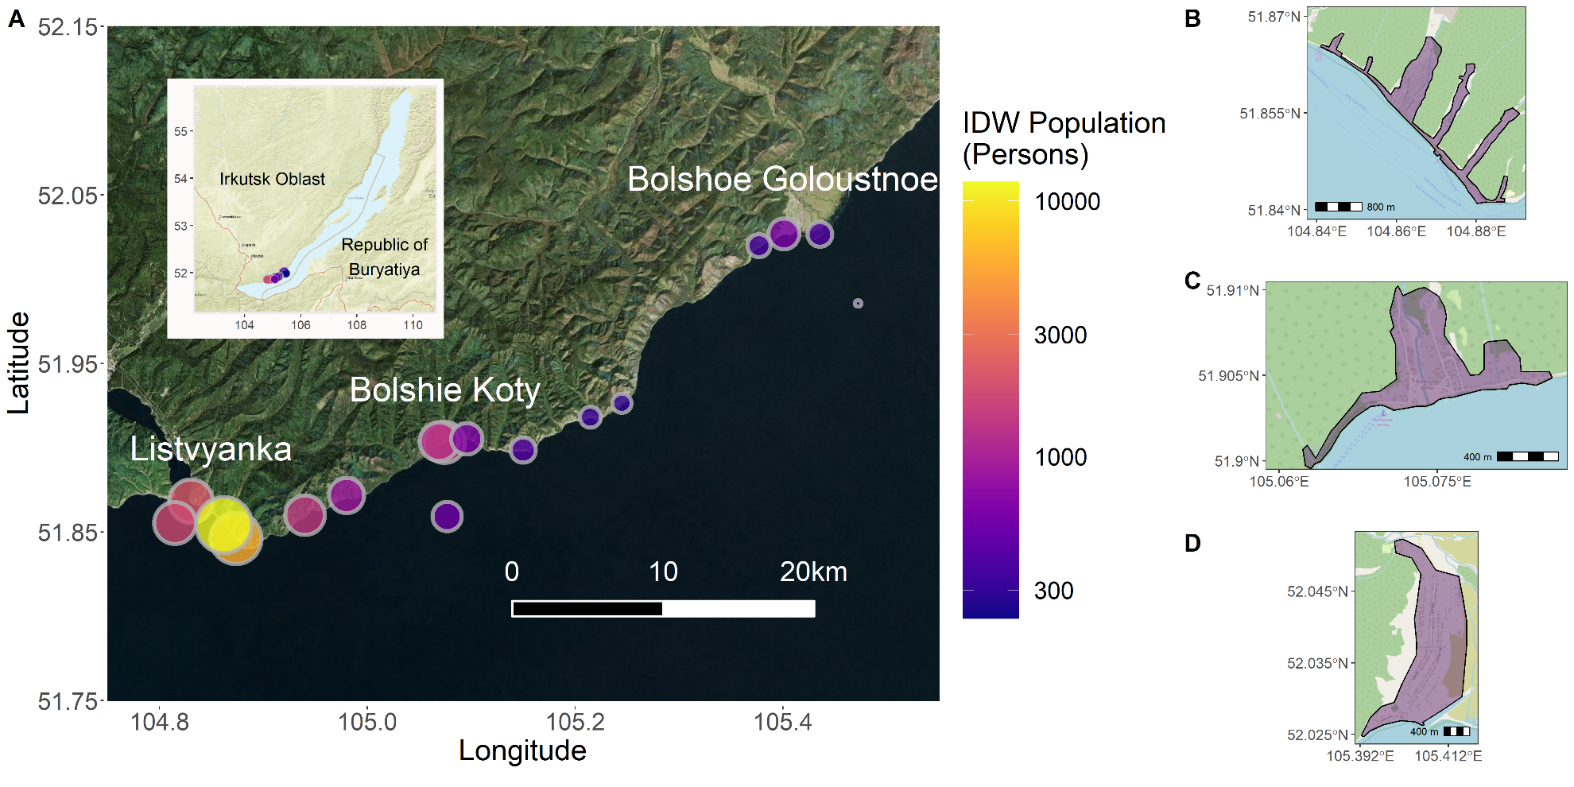Figure 1: Map of all sampling locations with sites sized and colored by IDW population (A) and shapefiles for the lakeside developments of Listvyanka (B), Bolshie Koty (C), and Bolshoe Goloustnoe (D). IDW population (A) was is shown on a log-scale to make IDW populations across three orders of magnitude more comparable.



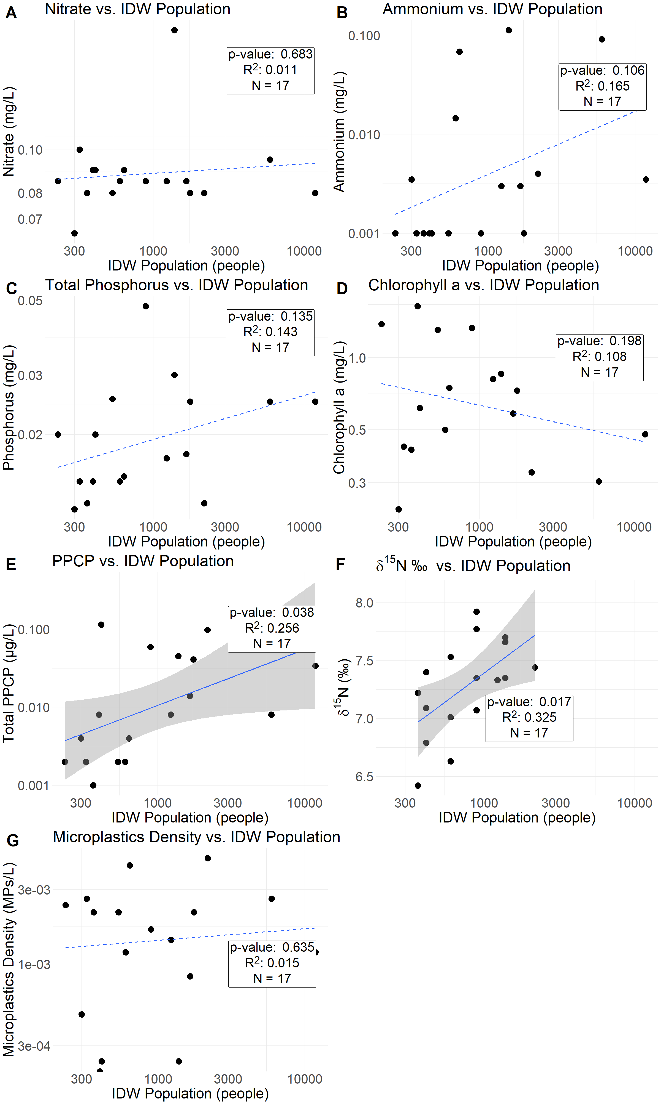

Figure 2: Nitrate (A), ammonium (B), total phosphorus (C), chlorophyll a (D), total PPCP (E), , macroinvertebrate δ15N (F), as well as microplastic density (G) values regressed against log-transformed inverse distance weighted (IDW) population. Statistical results are from linear regressions. Solid lines with error envelopes indicate significant relationships, whereas non-significant models have dotted regression lines without error envelopes.

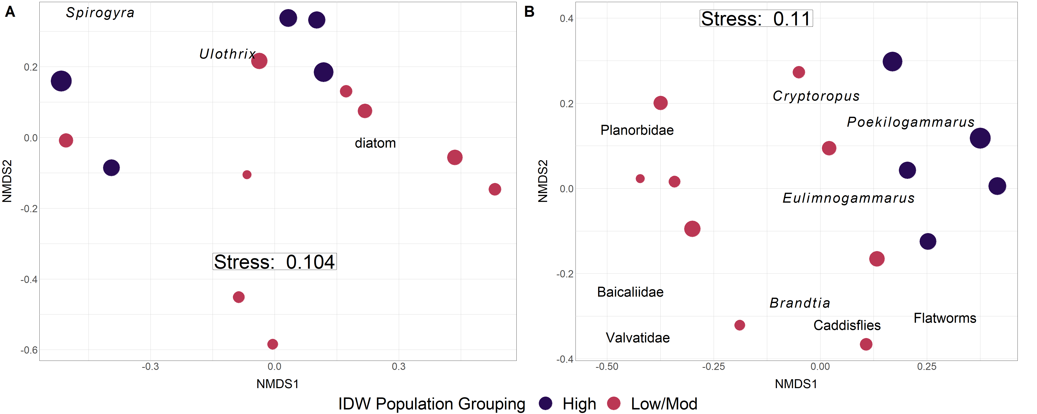

Figure 3: Periphyton (A) and macroinvertebrate (B) NMDS with Bray-Curtis dissimilarity. Points are sized by log-transformed IDW population and colored by grouped IDW population values. Taxonomic labels represent species scores, which are weighted averages of species contributions from site scores.

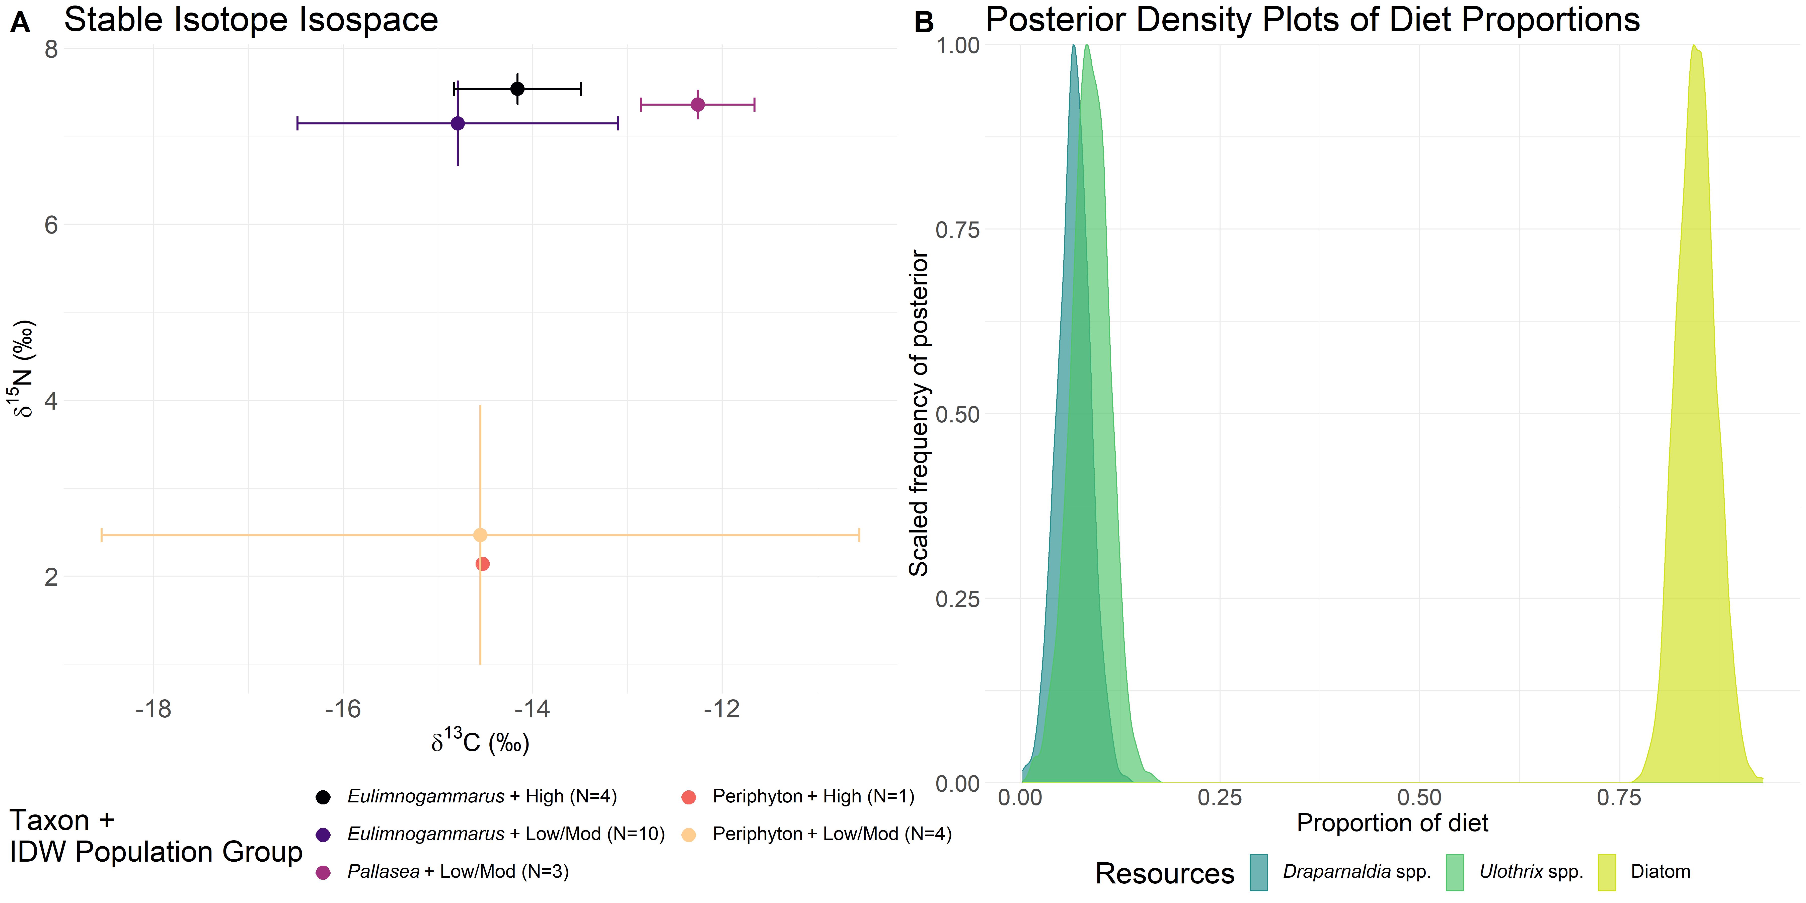

Figure 4: Food web structure analyses as assessed by δ13C or δ15N stable isotopes (A) and fatty acids (B). Mean and standard deviation δ13C and δ15N stable isotope values for littoral amphipods and periphyton are grouped by categorical IDW population (Table 3).

|  |  |  |  |  |  |  |
| --- | --- | --- | --- | --- | --- | --- |
| Table 1: Mean inter-site fatty acid proportion of each fatty acid grouping for each taxon. Standard deviations are reported in parentheses. These groups include saturated (SAFA), monounsaturated (MUFA), and short-chain (SCPUFA) as well as long-chain (LCPUFA) polyunsaturated fatty acids. | | | | | | |
| **Taxon** | **Number of sites** | **Branched** | **SAFA** | **MUFA** | **SCPUFA** | **LCPUFA** |
| *Draparnaldia* spp*.* | 4 | 0.000 (0.000) | 0.189 (0.014) | 0.088 (0.030) | 0.710 (0.045) | 0.012 (0.004) |
| *Eulimnogammarus cyaneus* | 2 | 0.002 (0.000) | 0.248 (0.015) | 0.309 (0.009) | 0.182 (0.033) | 0.259 (0.038) |
| *Eulimnogammarus verrucosus* | 6 | 0.000 (0.000) | 0.240 (0.061) | 0.385 (0.017) | 0.187 (0.036) | 0.188 (0.051) |
| *Eulimnogammarus vittatus* | 6 | 0.001 (0.000) | 0.241 (0.025) | 0.371 (0.039) | 0.216 (0.021) | 0.171 (0.032) |
| *Pallasea cancellus* | 3 | 0.001 (0.000) | 0.187 (0.062) | 0.359 (0.027) | 0.171 (0.051) | 0.282 (0.021) |
| Periphyton | 7 | 0.000 (0.000) | 0.284 (0.048) | 0.092 (0.054) | 0.550 (0.102) | 0.073 (0.006) |
| Snail | 3 | 0.002 (0.000) | 0.194 (0.018) | 0.123 (0.005) | 0.211 (0.021) | 0.470 (0.034) |

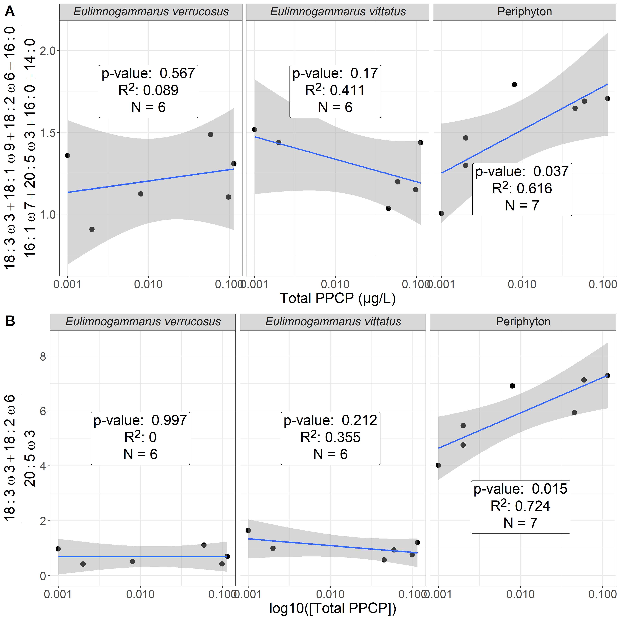

Figure 5: Ratio of filamentous:diatom-associated fatty acids (A) and essential fatty acids (B) across our PPCP gradient. Our first analysis (A) focused solely on green filamentous algal fatty acids (i.e., 18:3ω3, 18:1ω9, 18:2ω6, and 16:0 relative to diatom fatty acids (i.e., 20:5ω3, 16:1ω7, 16:0, 14:0) in relation to increasing PPCP concentrations. Our second analysis (B) focused solely on the essential fatty acids, which further highlights the trends observed in periphyton and macroinvertebrate grazers.

|  |  |  |  |  |  |  |  |  |  |
| --- | --- | --- | --- | --- | --- | --- | --- | --- | --- |
| Site | Latitude | Longitude | Depth (m) | Distance to Shore (m) | Air Temperature (°C) | Surface Temperature (°C) | Adjacent Population | Sampling Date (YYYMMDD) | Time of Sampling (hh:mm) |
| BK-1 | 51.90316 | 105.074 | 0.7 | 10 | 18 | 14 | 80 | 20150819 | 14:50 |
| BK-2 | 51.90365 | 105.069 | 0.9 | 17.5 | 19 | 13 | 80 | 20150820 | 8:49 |
| BK-3 | 51.90536 | 105.0957 | 0.8 | 10 | 18 | 14 | 80 | 20150820 | 11:00 |
| BGO-1 | 52.02693 | 105.401 | 0.9 | 18 | 20 | 13 | 0 | 20150821 | 8:41 |
| BGO-2 | 52.0197 | 105.3771 | 1.1 | 14 | 19 | 14 | 600 | 20150821 | 10:02 |
| BGO-3 | 52.02649 | 105.4358 | 0.7 | 21 | 18 | 16 | 600 | 20150821 | 18:35 |
| OS-1 | 51.98559 | 105.4724 | 900 | NA | 15 | NA | NA | 20150822 | 6:48 |
| KD-1 | 51.92646 | 105.245 | 0.8 | 20.75 | 23 | NA | 0 | 20150822 | 8:28 |
| KD-2 | 51.91807 | 105.2146 | 0.9 | 14.5 | 23 | 16 | 0 | 20150822 | 10:15 |
| MS-1 | 51.89863 | 105.1502 | 0.6 | 10.5 | 21 | 17 | 0 | 20150822 | 13:07 |
| SM-1 | 51.87152 | 104.9801 | 0.9 | 11.5 | 21 | 15 | 0 | 20150822 | 18:20 |
| LI-1 | 51.86825 | 104.8304 | 0.6 | 8.9 | 19 | 14 | 2000 | 20150823 | 8:01 |
| LI-2 | 51.84626 | 104.8736 | 0.8 | 9.4 | 21 | 15 | 2000 | 20150823 | 10:21 |
| LI-3 | 51.85407 | 104.8622 | 0.7 | 9.25 | 19.5 | 15 | 2000 | 20150823 | 12:00 |
| EM-1 | 51.86005 | 104.94 | 0.7 | 15.5 | 24.5 | 14 | 0 | 20150823 | 15:32 |
| OS-2 | 51.8553 | 104.8148 | 1300 | NA | 21 | NA | NA | 20150823 | 17:15 |
| OS-3 | 51.85911 | 105.0769 | 1400 | 5000 | NA | 14.5 | NA | 20150823 | NA |

Table S1: Location, depth, temperature and population information for each of the 17 sampling stations. “OS” refers to pelagic locations (i.e., “Offshore”), whereas other site abbreviations refer to littoral sampling locations. Surface temperatures correspond to water temperatures just below the water’s surface (i.e., depth of ~0.025 m).

|  |  |  |  |  |  |  |  |  |  |  |  |  |
| --- | --- | --- | --- | --- | --- | --- | --- | --- | --- | --- | --- | --- |
| Table S2: Average potential sewage indicator concentrations per sampling location. Where applicable, standard deviations are within parentheses. | | | | | | | | | | | | |
| Site | Ammonium (mg/L) | Nitrate (mg/L) | Total Phosphorus (mg/L) | Caffeine (µg/L) | Acetaminophen  (µg/L) | Paraxanthine  (µg/L) | Cotinine  (µg/L) | Microplastic Fragments(MPs/L) | Microplastic Fibers (MPs/L) | Microplastic Beads (MPs/L) | IDW population  (Number of People) | Categorical IDW population |
| BK-1 | 0.003 (0.000) | 0.085 (0.007) | 0.018 (0.001) | 0.011 | 0.001 | 0.002 | 0 | 0.000 (0.000) | 0.001 (0.002) | 0.000 (0.000) | 1653.727 | High |
| BK-2 | 0.003 (0.000) | 0.085 (0.007) | 0.017 (0.000) | 0.007 | 0.001 | 0 | 0 | 0.001 (0.001) | 0.000 (0.001) | 0.000 (0.000) | 1227.771 | Mod/Low |
| BK-3 | 0.068 (0.001) | 0.090 (0.000) | 0.015 (0.000) | 0.003 | 0.001 | 0 | 0 | 0.003 (0.002) | 0.001 (0.001) | 0.000 (0.000) | 639.411 | Mod/Low |
| BGO-1 | 0.015 (0.001) | 0.085 (0.007) | 0.014 (0.001) | 0 | 0.002 | 0 | 0 | 0.001 (0.001) | 0.000 (0.000) | 0.000 (0.000) | 601.355 | Mod/Low |
| BGO-2 | 0.001 (0.000) | 0.08 (0.000) | 0.013 (0.001) | 0 | 0.001 | 0 | 0 | 0.000 (0.000) | 0.002 (0.003) | 0.000 (0.000) | 363.704 | Mod/Low |
| BGO-3 | 0.001 (0.000) | 0.090 (0.000) | 0.014 (0.001) | 0.005 | 0.003 | 0 | 0 | 0.000 (0.000) | 0.000 (0.000) | 0.000 (0.000) | 398.838 | Mod/Low |
| OS-1 | 0.001 (0.000) | 0.085 (0.007) | 0.020 (0.000) | 0 | 0.001 | 0 | 0.001 | 0.002 (0.001) | 0.000 (0.000) | 0.000 (0.000) | 233.208 | Mod/Low |
| KD-1 | 0.004 (0.001) | 0.065 (0.007) | 0.012 (0.000) | 0.003 | 0.001 | 0 | 0 | 0.000 (0.000) | 0.000 (0.000) | 0.000 (0.000) | 300.634 | Mod/Low |
| KD-2 | 0.001 (0.000) | 0.100 (0.000) | 0.015 (0.001) | 0.001 | 0.001 | 0 | 0 | 0.001 (0.001) | 0.002 (0.000) | 0.000 (0.000) | 325.488 | Mod/Low |
| MS-1 | 0.001 (0.000) | 0.090 (0.000) | 0.020 (0.000) | 0.064 | 0.035 | 0.015 | 0 | 0.000 (0.000) | 0.000 (0.000) | 0.000 (0.000) | 412.517 | Mod/Low |
| SM-1 | 0.001 (0.000) | 0.085 (0.007) | 0.048 (0.000) | 0.042 | 0.012 | 0.005 | 0 | 0.000 (0.000) | 0.002 (0.002) | 0.000 (0.000) | 893.950 | Mod/Low |
| LI-1 | 0.004 (0.000) | 0.080 (0.000) | 0.013 (0.001) | 0.05 | 0.04 | 0.006 | 0.002 | 0.004 (0.001) | 0.000 (0.000) | 0.001 (0.001) | 2179.963 | High |
| LI-2 | 0.091 (0.001) | 0.095 (0.007) | 0.025 (0.000) | 0.001 | 0.007 | 0 | 0 | 0.001 (0.001) | 0.001 (0.001) | 0.000 (0.000) | 5937.413 | High |
| LI-3 | 0.004 (0.001) | 0.08 (0.000) | 0.025 (0.000) | 0.027 | 0.002 | 0.002 | 0.003 | 0.000 (0.001) | 0.000 (0.000) | 0.001 (0.001) | 11824.748 | High |
| EM-1 | 0.113 (0.002) | 0.185 (0.007) | 0.030 (0.000) | 0.029 | 0.014 | 0.002 | 0 | 0.000 (0.000) | 0.000 (0.000) | 0.000 (0.000) | 1383.160 | High |
| OS-2 | 0.001 (0.000) | 0.080 (0.000) | 0.025 (0.000) | 0.033 | 0.001 | 0.004 | 0.003 | 0.000 (0.000) | 0.002 (0.002) | 0.000 (0.000) | 1753.554 | High |
| OS-3 | 0.001 (0.000) | 0.080 (0.000) | 0.026 (0.001) | 0.001 | 0.001 | 0 | 0 | 0.000 (0.000) | 0.002 (0.001) | 0.000 (0.000) | 537.304 | Mod/Low |

|  |  |  |
| --- | --- | --- |
| Table S3: Macroinvertebrate taxonomic groupings for abundance estimates. Amphipod taxa were defined as in Takhteev & Didorenko, 2015; mollusk taxa were defined as in Sitnikova, 2012. | | |
| **Amphipoda** | **Mollusca** | **Other** |
| *Brandtia latissima intermida* (Dorogostaiskii 1930) | Acroloxidae | Asellidae |
| *Brandtia latissima lata* (Dybowsky 1874) | Baicaliidae | Caddisflies |
| *Brandtia latissima latior* (Dybowsky 1874) | Benedictidate | Hirudinea |
| *Brandtia latissima latissima* (Gerstfeldt 1858) | Maackia | Planaria |
| *Brandtia parasitica parasitica* (Dybowsky 1874) | Planorbidae |  |
| *Cryptoropus inflatus* (Dybowsky 1874) | Valvatidae |  |
| *Cryptoropus pachytus* (Dybowsky 1874) |  |  |
| *Cryptoropus rugosus* (Dybowsky 1874) |  |  |
| *Eulimnogammarus capreolus* (Dybowsky 1874) |  |  |
| *Eulimnogammarus cruentes* (Dorogostaiskii 1930) |  |  |
| *Eulimnogammarus cyaneus* (Dybowsky 1874) |  |  |
| *Eulimnogammarus grandimanus* (Bazikalova 1945) |  |  |
| *Eulimnogammarus maacki* (Gerstfeldt 1858) |  |  |
| *Eulimnogammarus marituji* (Bazikalova 1945) |  |  |
| *Eulimnogammarus verucossus* (Gerstfeldt 1858) |  |  |
| *Eulimnogammarus viridis viridis* (Dybowsky 1874) |  |  |
| *Eulimnogammarus vittatus* (Dybowsky 1874) |  |  |
| *Pallasea brandtia brandita* (Dybowsky 1874) |  |  |
| *Pallasea brandtii tenera* (Sovinskii 1930) |  |  |
| *Pallasea cancelloides* (Gerstfeldt 1858) |  |  |
| *Pallasea cancellus* (Pallas 1776) |  |  |
| *Pallasea viridis* (Garjajev 1901) |  |  |
| *Poekilogammarus crassimus* (Sovinskii 1915) |  |  |
| *Poekilogammarus ephippiatus* (Dybowsky 1874) |  |  |
| *Poekilogammarus megonychus perpolitus* (Takhteev 2002) |  |  |
| *Poekilogammarus pictus* (Dybowsky 1874) |  |  |

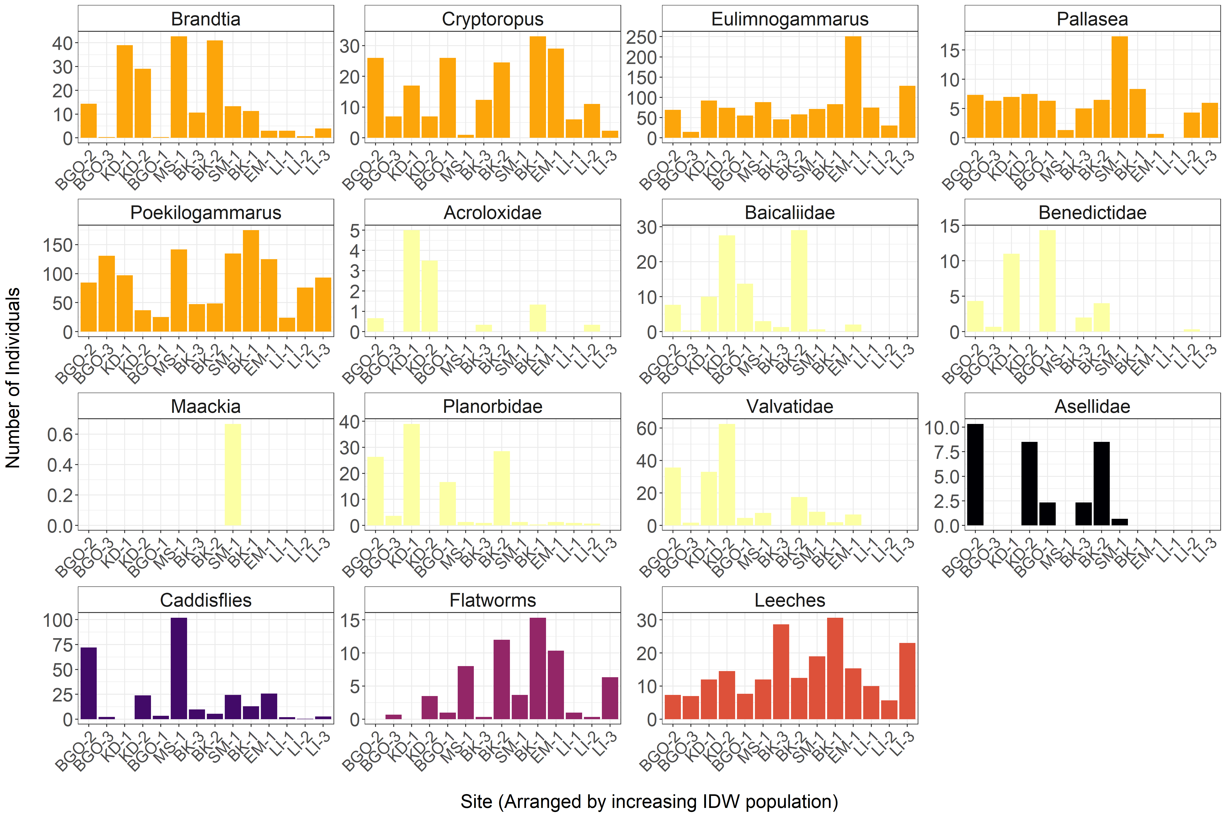Figure S1: Average abundance of main benthic macroinvertebrate taxonomic groups across sampling transect. Sites are ordered left-to-right by increasing inverse distance weighted population. Each distinct color represents a broad taxon (‘Orange’ = Amphipoda; ‘Yellow’ = Molluska; ‘Black’ = Aseillidae; ‘Dark Purple’ = Caddisflies; ‘Magenta’ = Flatworms; ‘Dark Pink’ = Leeches).



Figure S2: With-group-sum-of-squares (wss) for increasing number of k-mediod clusters for periphyton (A) and invertebrate (B) community data. In the case of periphyton data, wss decreases most markedly with three clusters, whereas invertebrate community abundance is best described by potentially two or three clusters.



Figure S3: Average silhouette width for increasing number of k-medoid clusters for periphyton (A) and invertebrate (B) community data. In the case of periphyton data, average silhouette width decreased most markedly with three clusters, whereas invertebrate community abundance is best described by two or three clusters as the average silhouette width for both two and three clusters was highest before beginning to decrease.



Figure S4: Weighted Pair-Group Centroid Clustering (WPGMC) for periphyton (A) and macroinvertebrate (B) community compositions. Approximately unbiased (au) p-values are computed by multiscale bootstrap resampling and displayed in red on the left side of each node. Bootstrapped probabilities (bp) are displayed in green on the right side of each node. Unlike k-mediods, WPGMC uses a hierarchical approach to assign clusters, which are bootstrapped in order to generated a probability of group membership. This technique suggested that both periphyton and macroinvertebrates could be grouped in two clusters. Grouping macroinvertebrates into three clusters was possible; however, three clusters resulted in 8 of the 14 sampling locations being assigned to a group. In contrast, two groups enabled 13 of the 14 sampling locations to be assigned to a cluster.

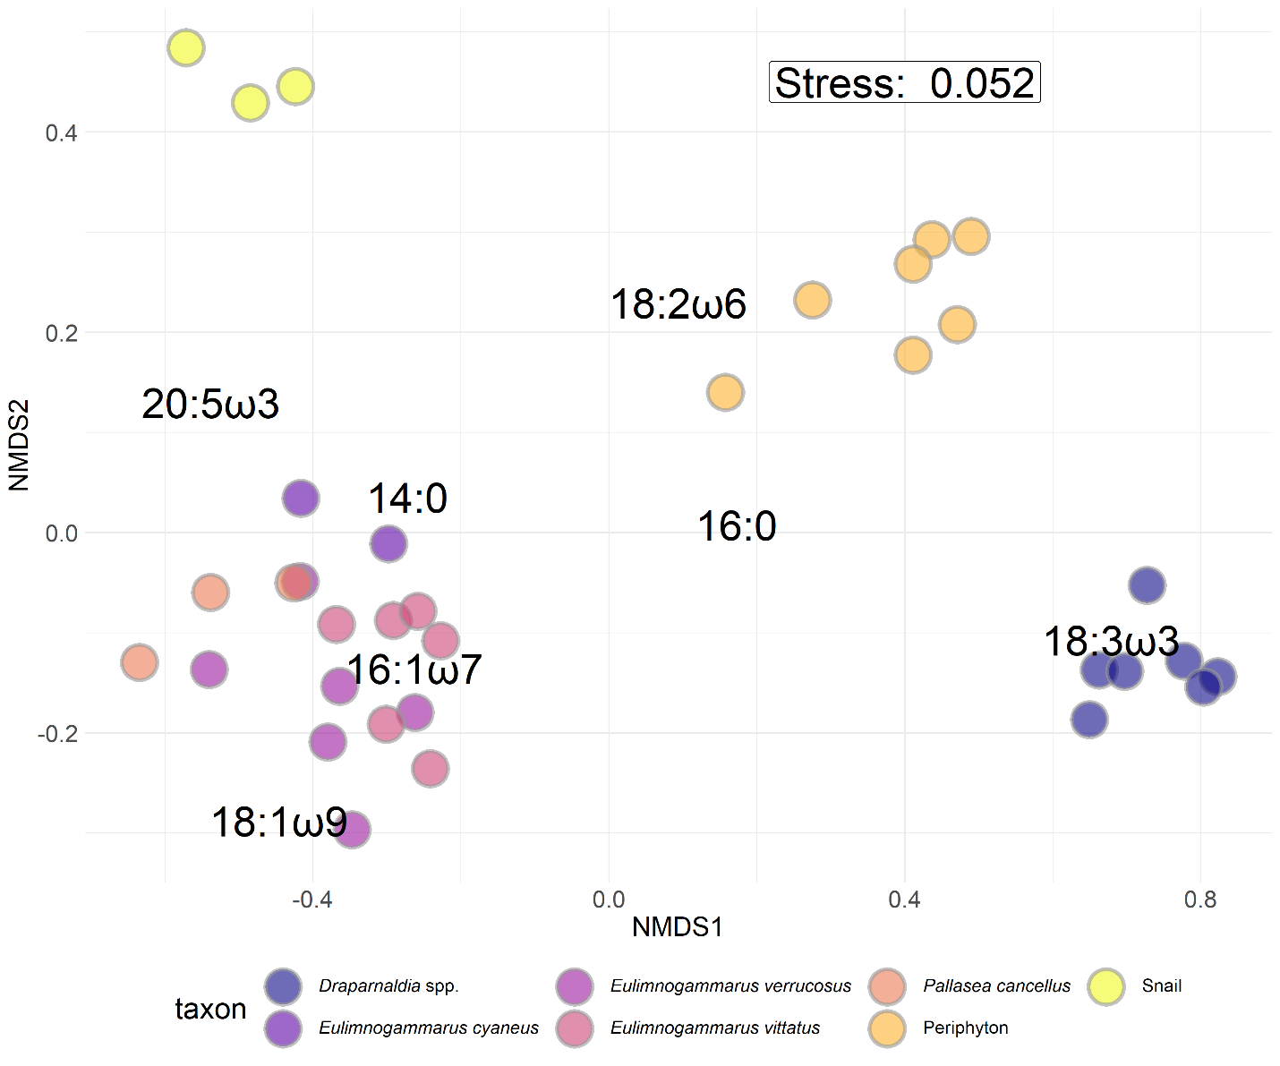

Figure S5: NMDS with Bray-Curtis dissimilarity of proportional fatty acid compositions for each macroinvertebrate and primary producer collected. *Eulimnogammarus* and *Pallasea* are endemic amphipod genera. *Draparnaldia* spp. are endemic filamentous algae that are large and form very dense mats easily collected where it occurs. *Draparnaldia* spp.occurred in large, visible colonies, allowing us to sample and analyze just the *Draparnaldia* spp. fatty acids. Because *Draparnaldia* spp. fatty acids were dominated by 18:3ω3 more so than periphyton, they formed their own cluster. Snails were not identified to species prior to fatty acid analysis. Interspecific variation in fatty acid composition tended to be larger than intraspecific variation, implying that fatty acid signatures were largely species-specific and not environmentally driven.

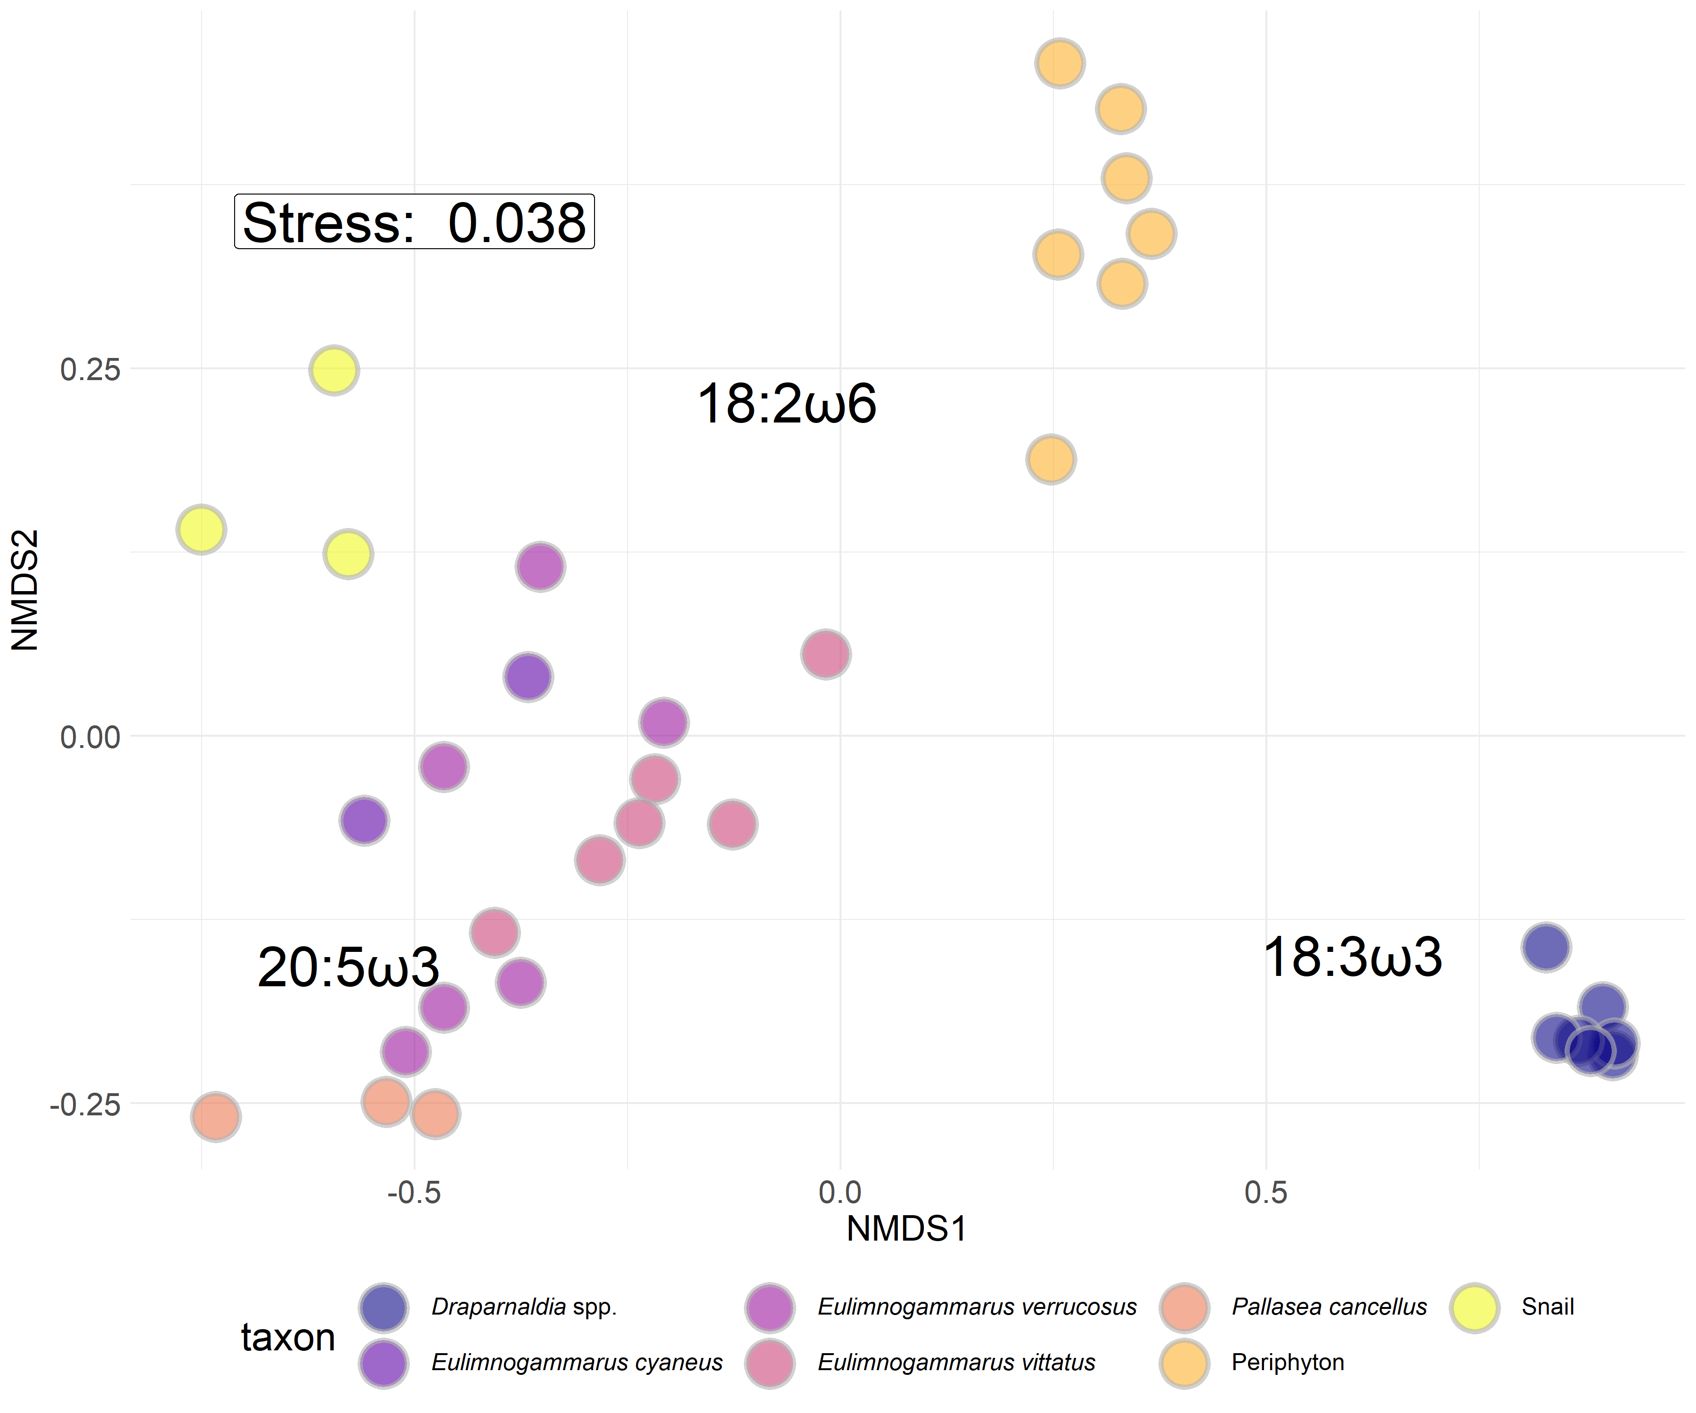

Figure S6: NMDS with Bray-Curtis dissimilarity of proportional biologically essential fatty acid compositions for each macroinvertebrate and primary producer collected. *Eulimnogammarus* and *Pallasea* are endemic amphipod genera. *Draparnaldia* spp. are endemic filamentous algae that are large and form very dense mats easily collected where it occurs. *Draparnaldia* spp. occurred in large, visible colonies, allowing us to sample and analyze just the *Draparnaldia* spp. fatty acids. Because *Draparnaldia* spp. fatty acids were dominated by 18:3ω3 more so than periphyton, they formed their own cluster. Snails were not identified to species prior to fatty acid analysis. Interspecific variation in fatty acid composition tended to be larger than intraspecific variation, implying that fatty acid signatures were largely species-specific and not environmentally driven.

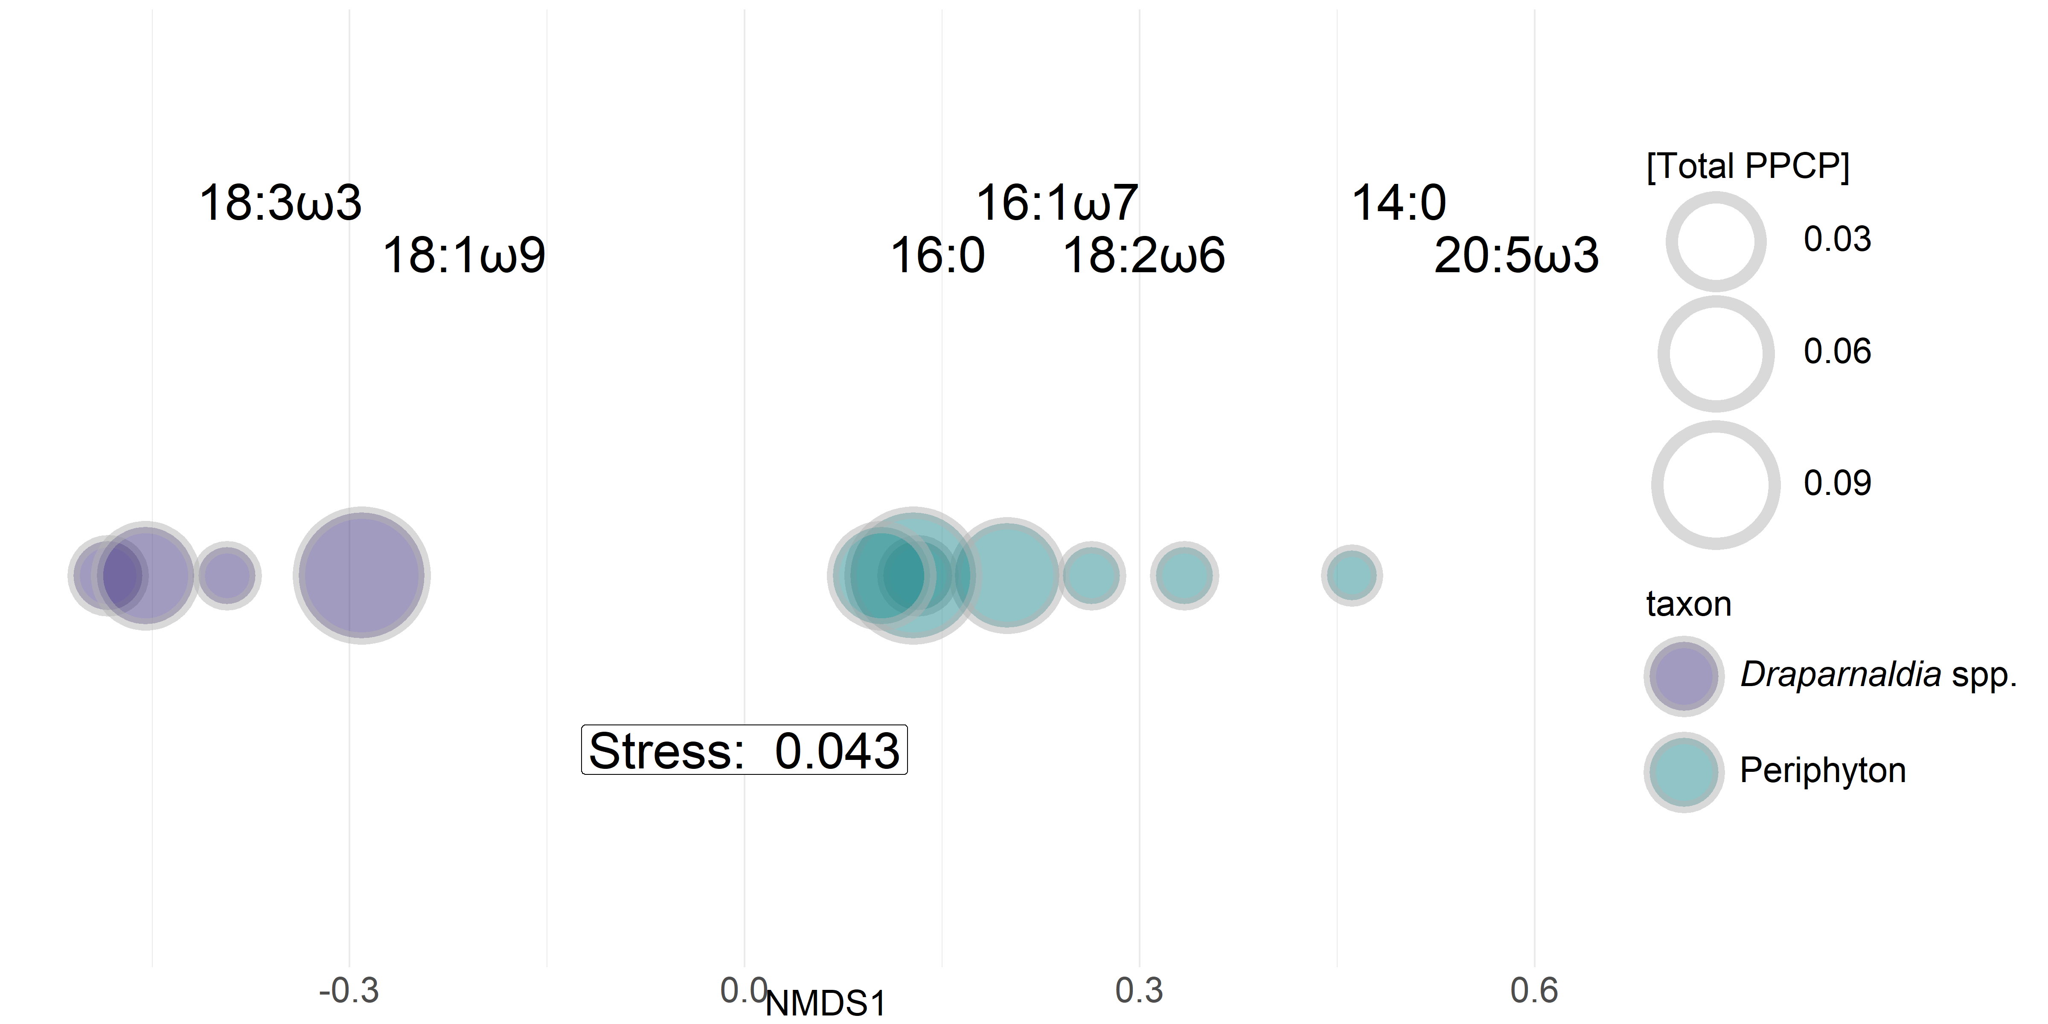

Figure S7: One-dimensional NMDS with Bray-Curtis similarity of seven fatty acids of interest for primary producers. Fatty acid scores are placed above shapes. Shapes are sized by total PPCP concentration. Periphyton (blue-green) tend to increase in size from right-to-left, suggesting that periphyton tend to include more 18:3ω3 and 18:1ω9 (indicators of green algal taxa) with an increasing sewage signal. In contrast, *Draparnaldia* spp. (purple) fatty acids tend to remain consistent across the sewage gradient.

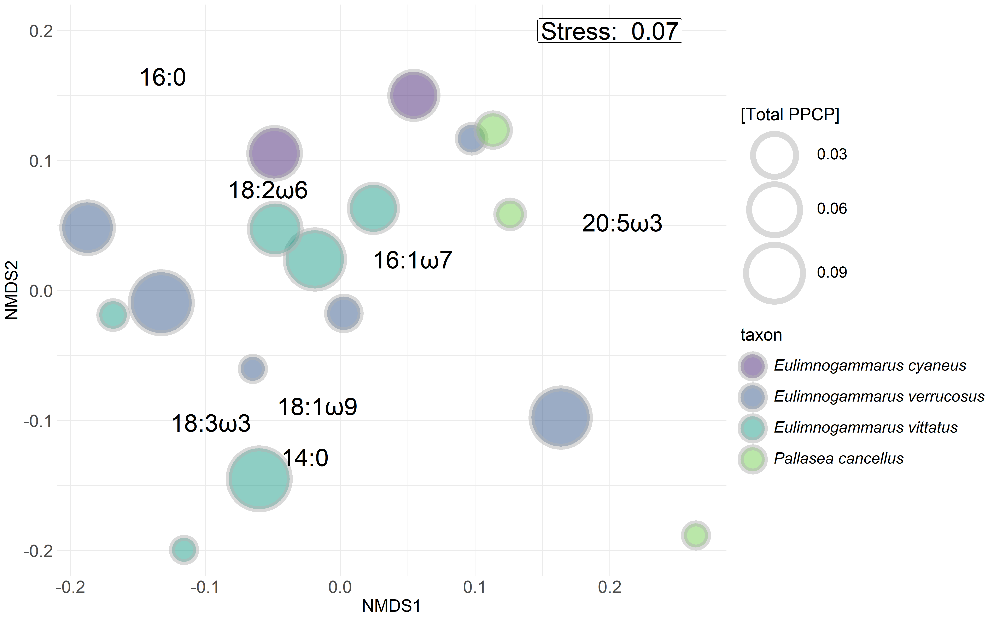Figure S8: NMDS with Bray-Curtis similarity of seven targeted fatty acids of interest for primary producers. Points are sized by total PPCP concentration. Visually, there appears to be no distinct separation among or within taxa unlike patterns observed with periphyton (Figure S7).

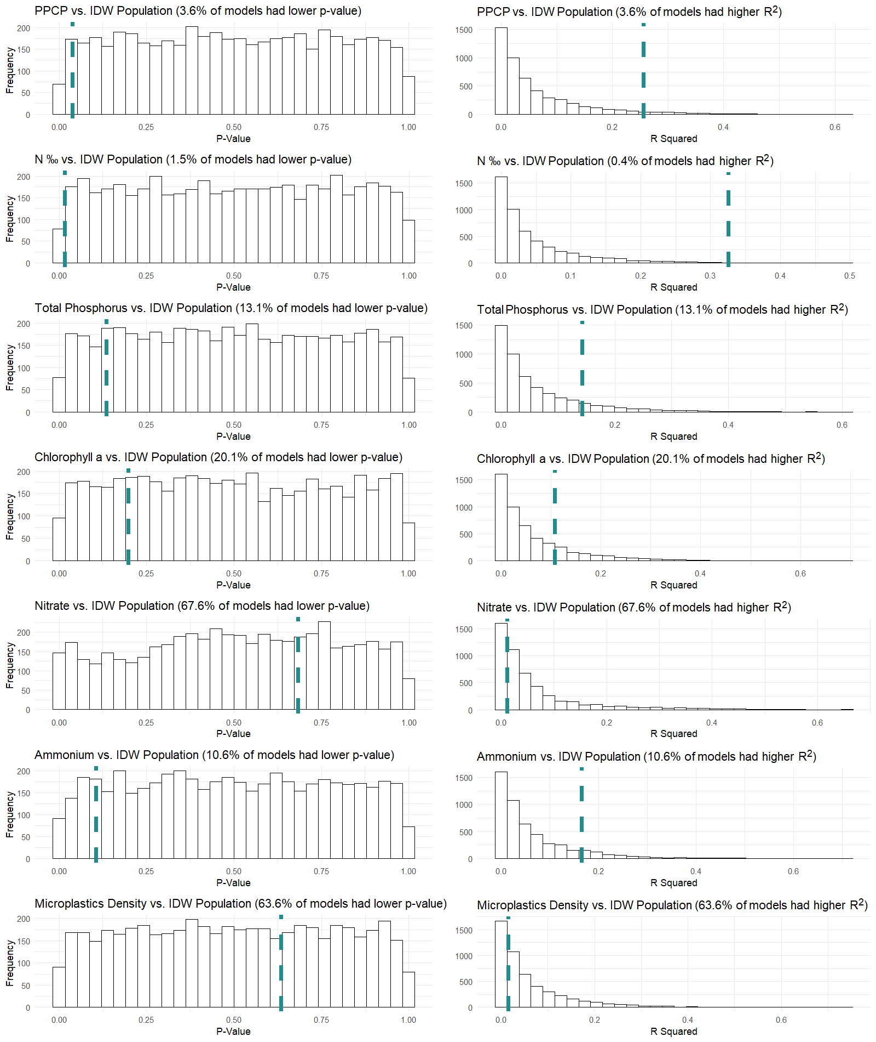

Figure S9: Distributions of p- and R­2 values for sewage indicator values in response to IDW population. Models were generated from 5,000 data permutations. Histograms represent p- and R2 values estimated from linear models fit with permuted sewage indicator data. The vertical dashed line in each plot represents the p- and R2 value obtained from the linear model fit with non-permuted data. The percent of p- and R2 values occuring respectively below and above values estimated from the non-permuted values are listed in the title of each plot. In the case when a model fit is non-random, the dashed green line should be in the lower 5% tail end for p-values and in the upper 5% for R2 values.

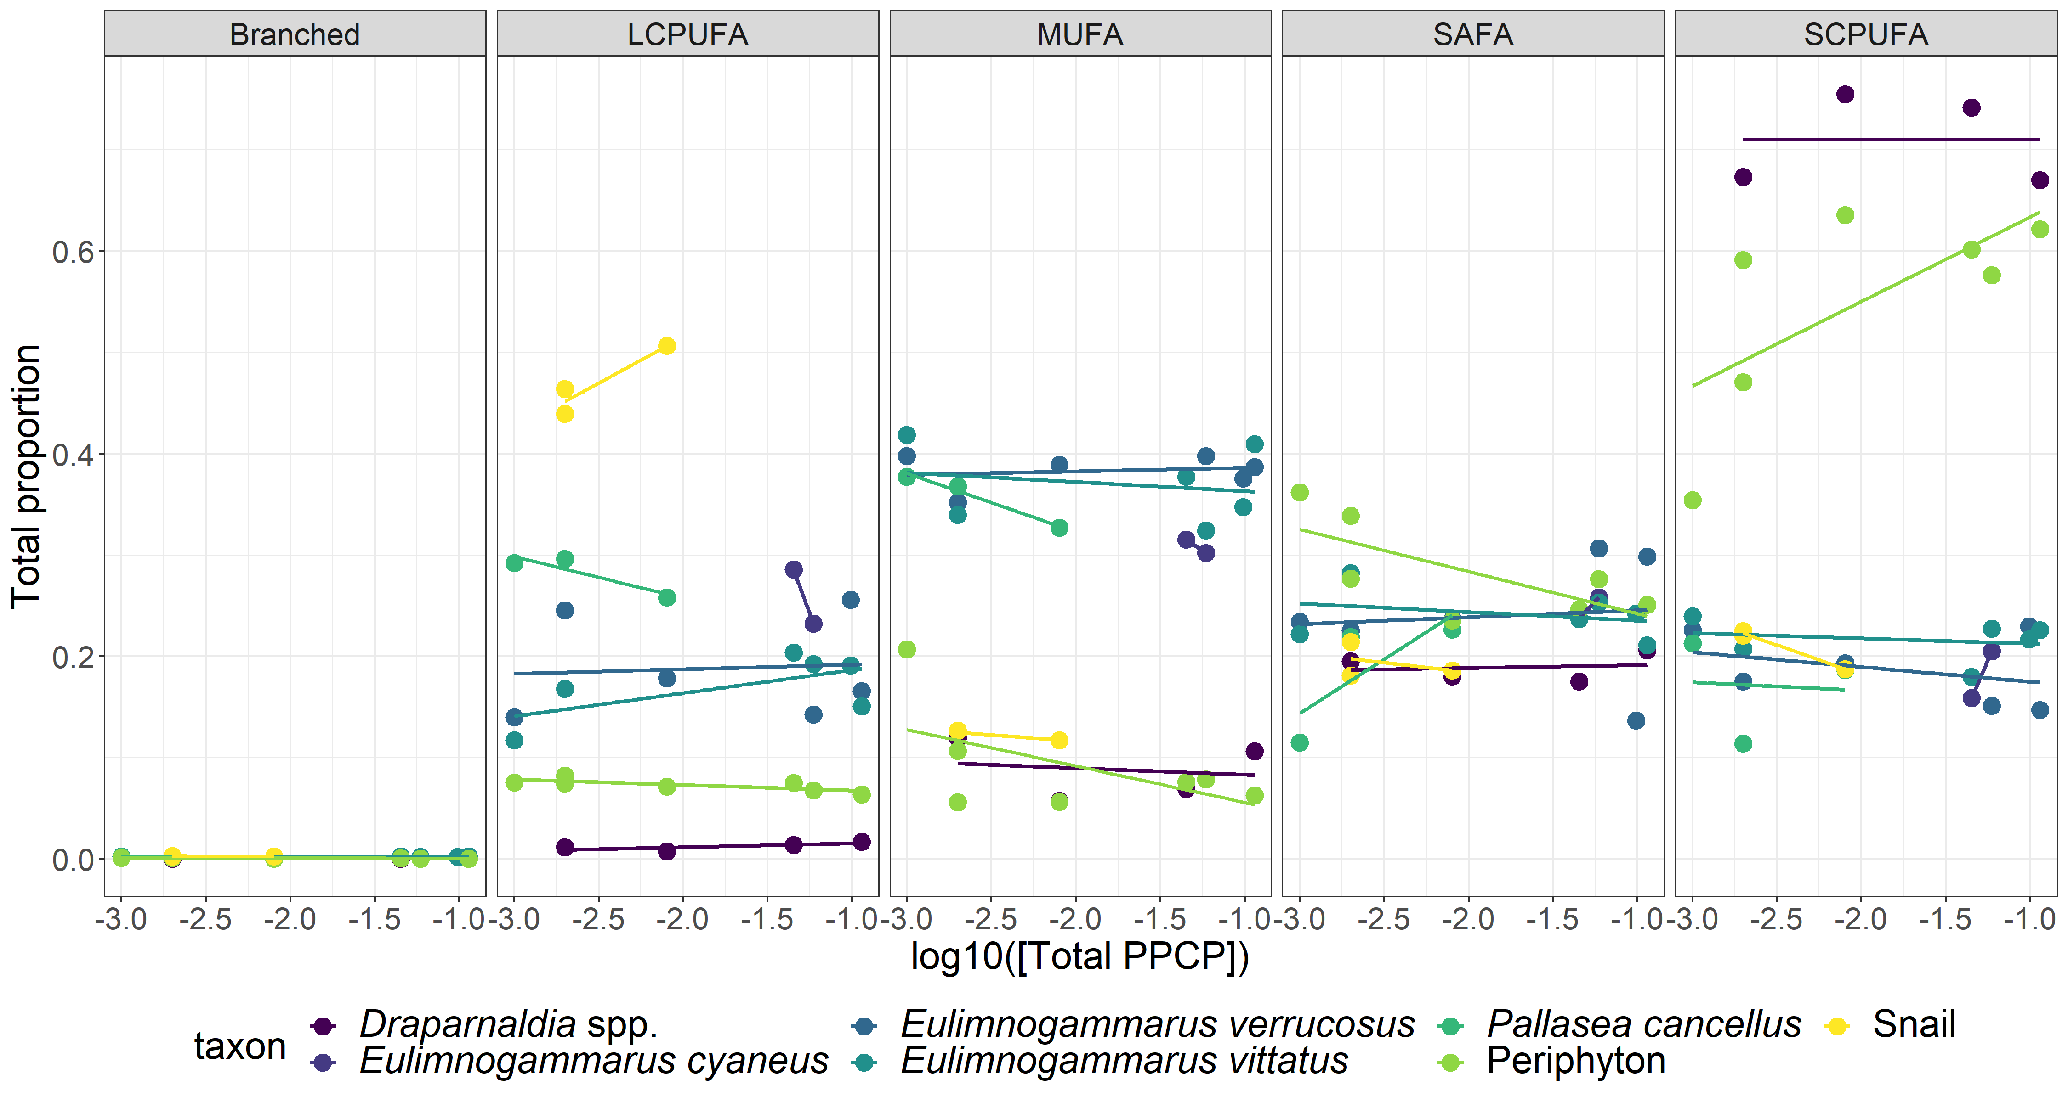

Figure S10: Proportions of major fatty aid groups (as defined in Table S2) across the sewage gradient. Primary producers (*Draparnaldia* spp. and periphyton) were largely characterized by SCPUFAs, amphipods were largely associated with high MUFA abundance, and snails were generally characterized with high LCPUFA abundance. Across the sewage gradient, periphyton SCPUFA tended to increase, which lead to more targeted analyses on which specific fatty acids were increasing. In contrast to periphyton, all other taxa remained consistent with respect to fatty acid proportions across the sewage gradient.

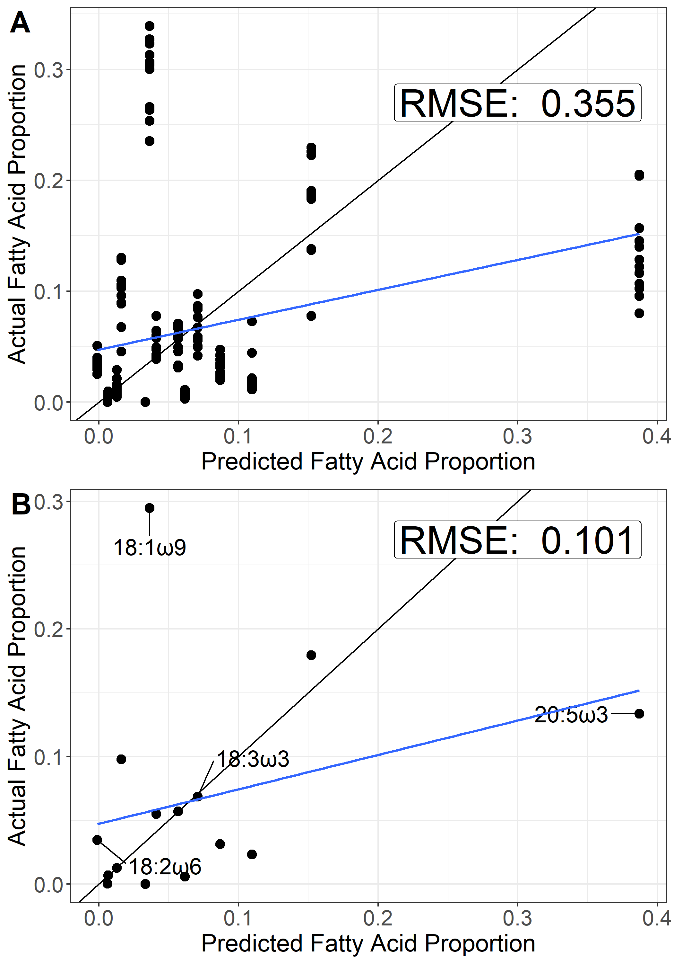

Figure S11: 1:1 line (black) of Predicted vs. Actual consumer fatty acid proportions for (A) individual samples and (B) sample averages. A linear model (blue) is also plotted to demonstrate deviation from the 1:1 line. Essential fatty acids included in this analysis as well as fatty acids deviating exceptionally from the 1:1 line, such as 18:1ω9, are labelled.

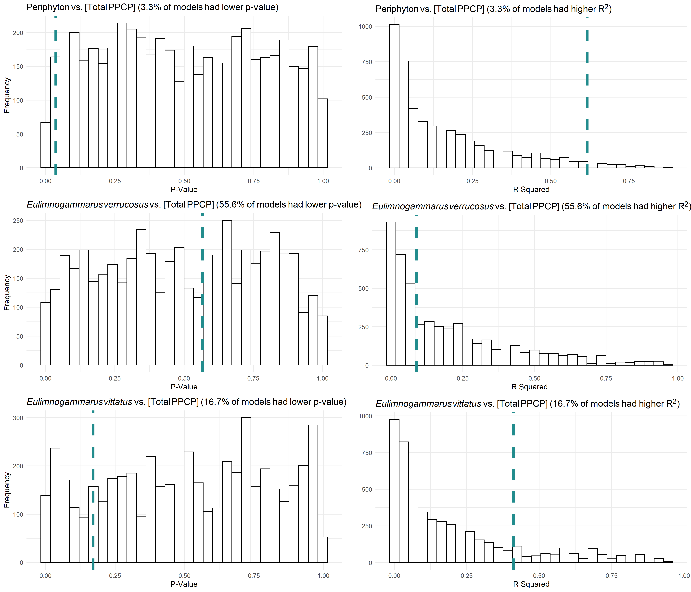

Figure S12: Distributions of p- and R­2 values for filamentous:diatom fatty acid ratios in response to total PPCP concentrations for permuted data. Models were generated from 5,000 data permutations. Histograms represent p- and R2 values estimated from linear models fit with permuted sewage indicator data. The vertical dashed line in each plot represents the p- and R2 value obtained from the linear model fit with non-permuted data. The percent of p- and R2 values occuring respectively below and above values estimated from the non-permuted values are listed in the title of each plot. In the case when a model fit is non-random, the dashed green line should be in the lower 5% tail end for p-values and in the upper 5% for R2 values.

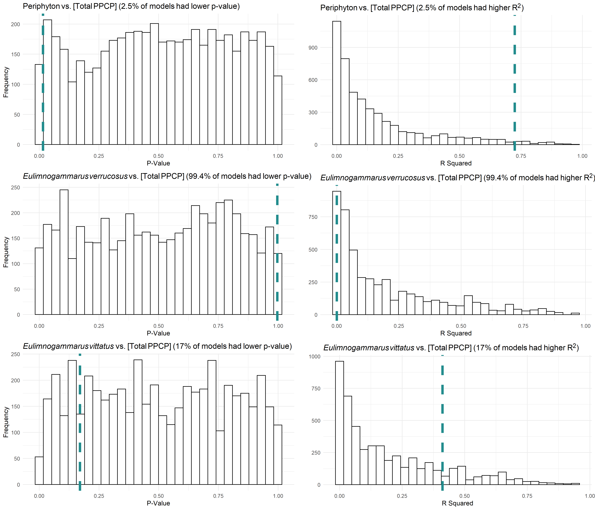

Figure S13: Distributions of p- and R­2 values for filamentous:diatom essential fatty acid ratios in response to total PPCP concentrations for permuted data. Models were generated from 5,000 data permutations. Histograms represent p- and R2 values estimated from linear models fit with permuted sewage indicator data. The vertical dashed line in each plot represents the p- and R2 value obtained from the linear model fit with non-permuted data. The percent of p- and R2 values occuring respectively below and above values estimated from the non-permuted values are listed in the title of each plot. In the case when a model fit is non-random, the dashed green line should be in the lower 5% tail end for p-values and in the upper 5% for R2 values.

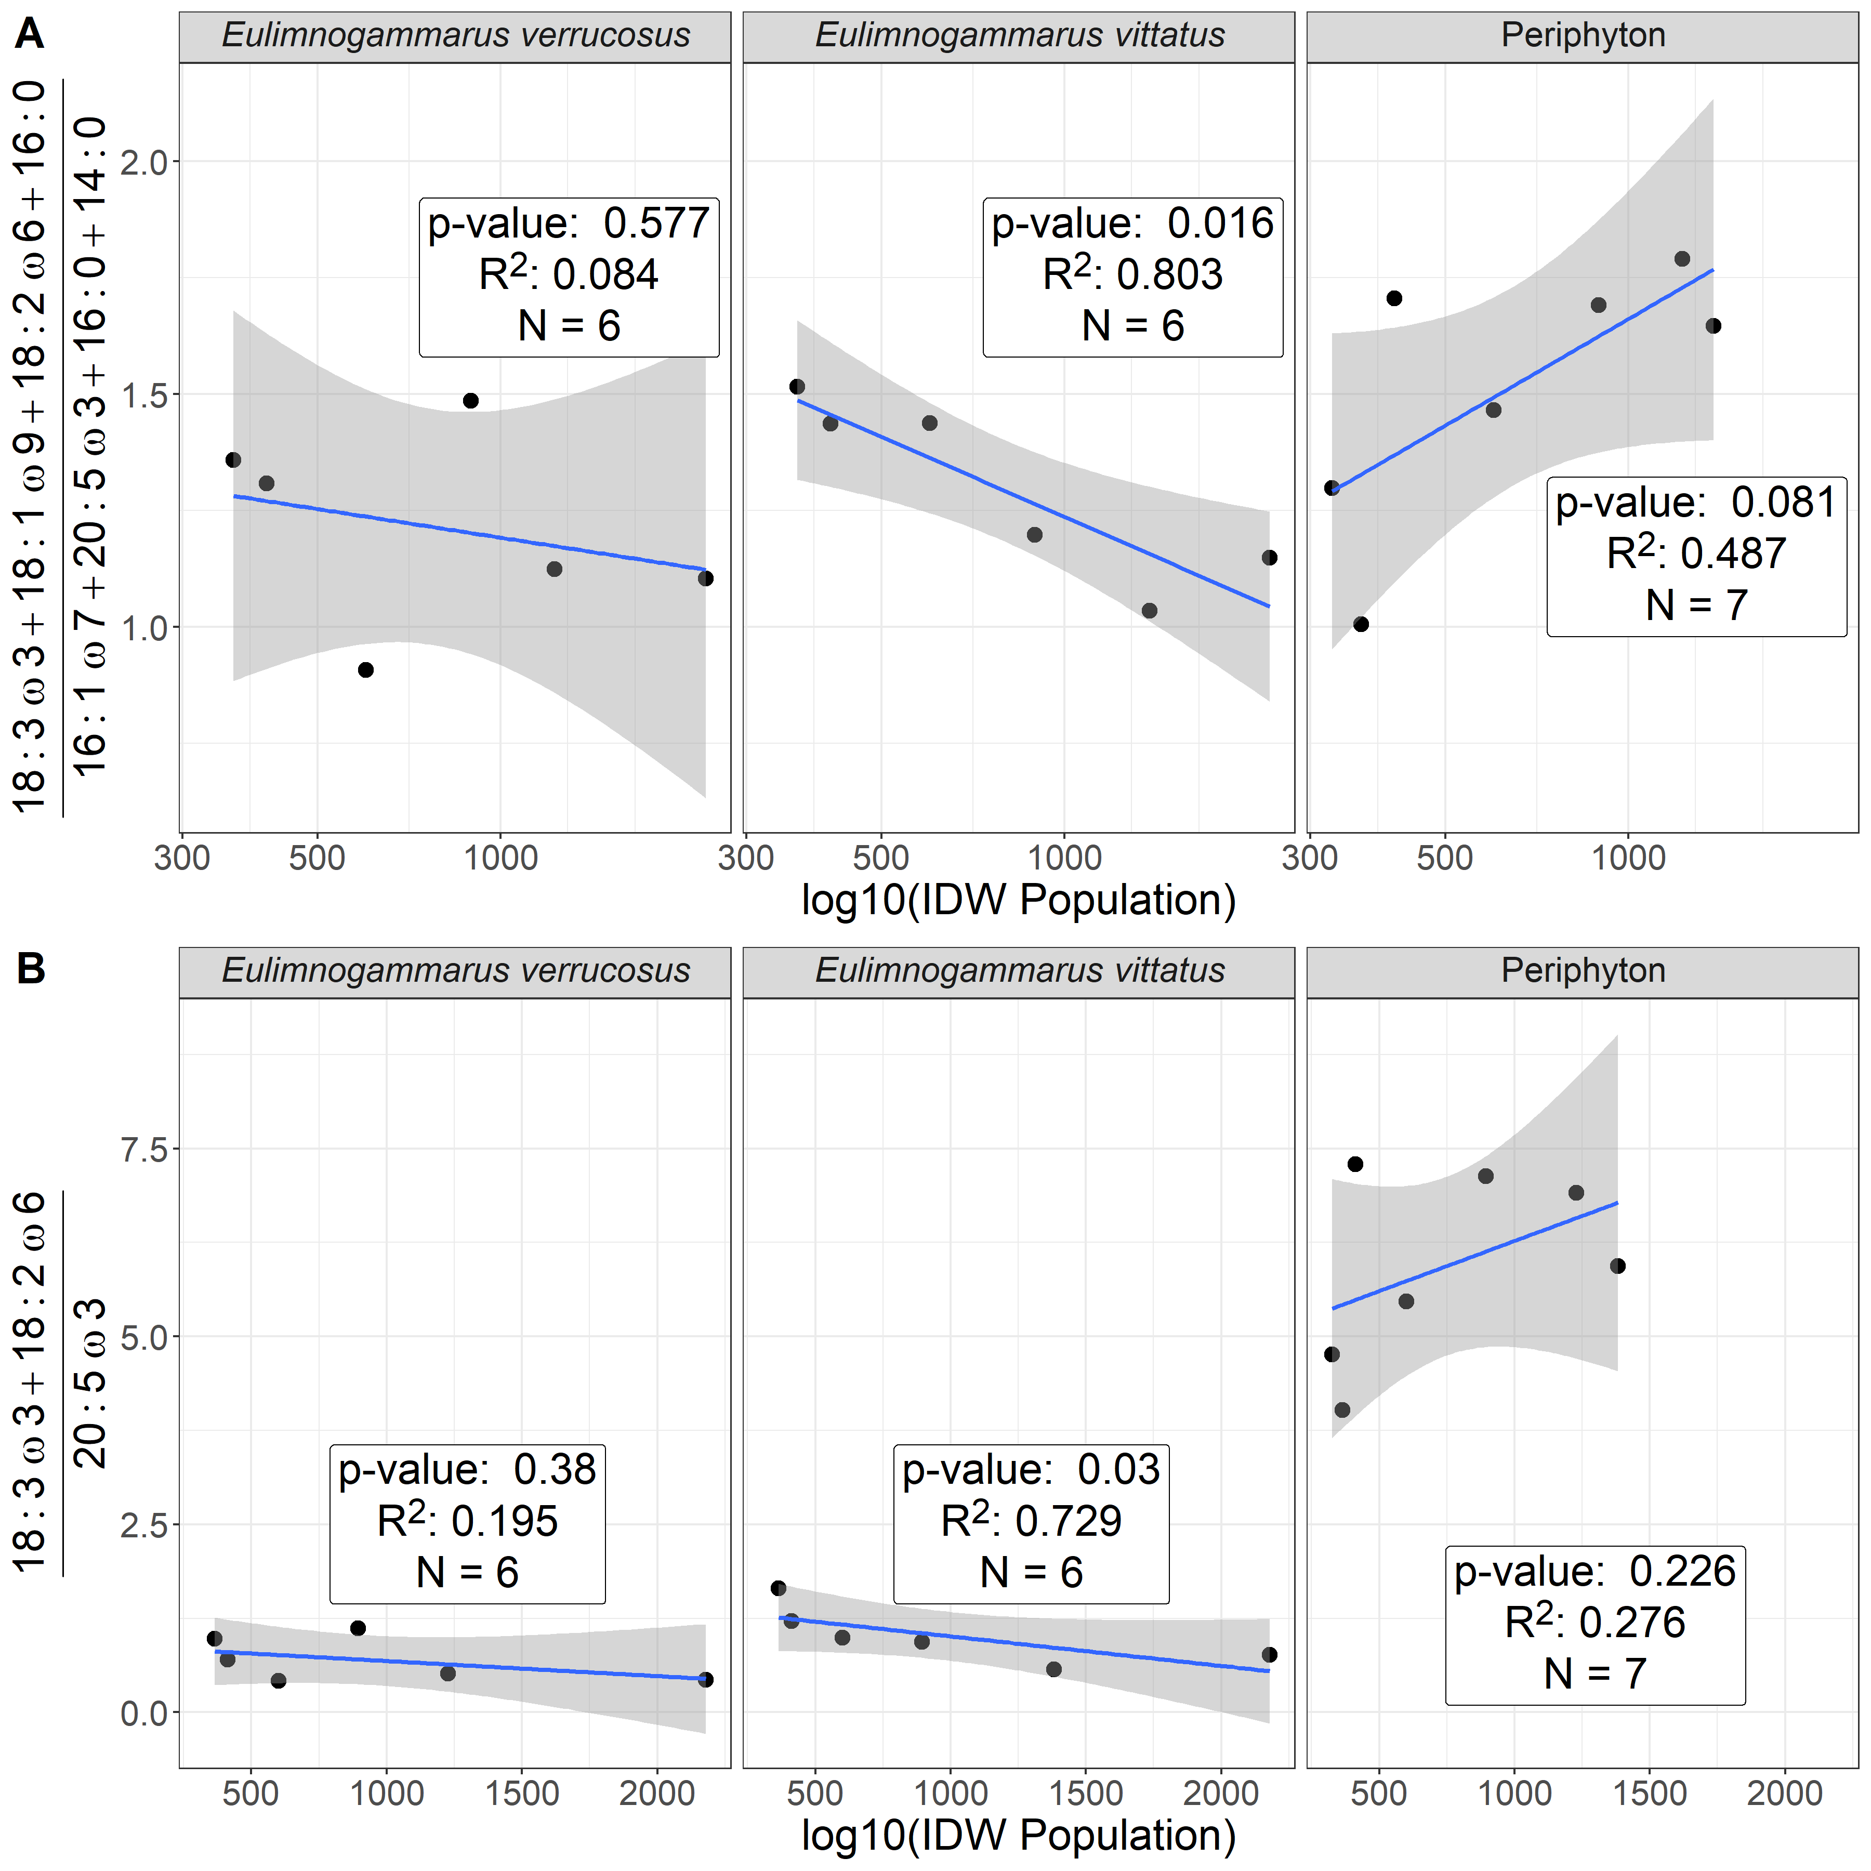

Figure S14: Ratio of filamentous:diatom-associated fatty acids (A) and essential fatty acids (B) across our IDW Population gradient. Our first analysis (A) focused solely on green filamentous algal fatty acids (i.e., 18:3ω3, 18:1ω9, 18:2ω6, and 16:0 relative to diatom fatty acids (i.e., 20:5ω3, 16:1ω7, 16:0, 14:0) in relation to increasing PPCP concentrations. This first analysis suggested periphyton, to some degree, tended to reflect an increasing green, filamentous signature relative to diatoms, which corroborates analyses showing community compositional shifts (Figure 4). Macroinvertebrate signatures generally remained consistent, although *E. vittatus*’s signatures generally reflected an increased diatom signature over the gradient. Our second analysis (B) focused solely on the essential fatty acids. These same general patterns were also observed when using PPCP concentrations in place of IDW population (Figure 7).

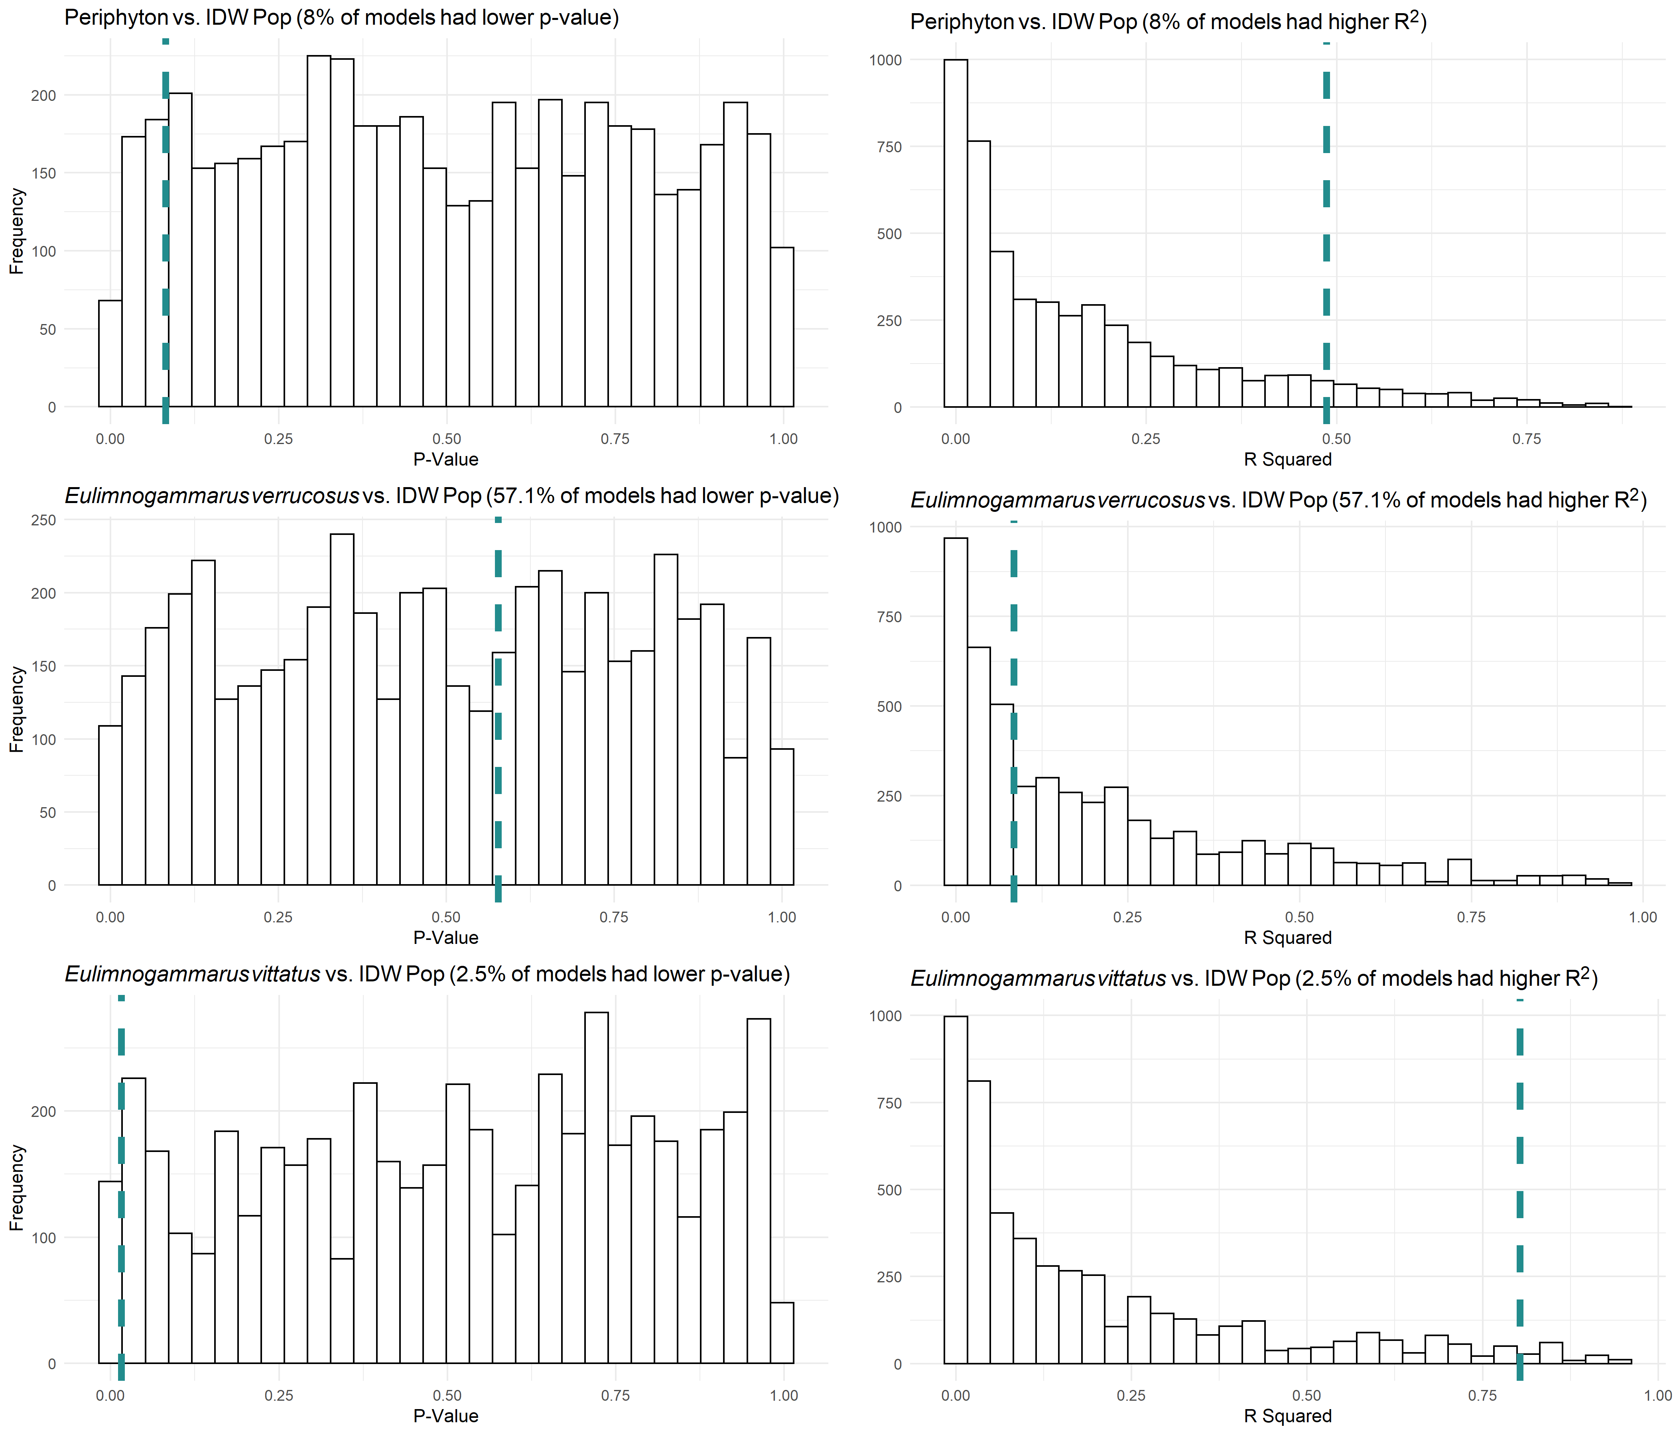

Figure S15: Distributions of p- and R­2 values for filamentous:diatom fatty acid ratios in response to IDW population for permuted data. Models were generated from 5,000 data permutations. Histograms represent p- and R2 values estimated from linear models fit with permuted sewage indicator data. The vertical dashed line in each plot represents the p- and R2 value obtained from the linear model fit with non-permuted data. The percent of p- and R2 values occuring respectively below and above values estimated from the non-permuted values are listed in the title of each plot. In the case when a model fit is non-random, the dashed green line should be in the lower 5% tail end for p-values and in the upper 5% for R2 values.

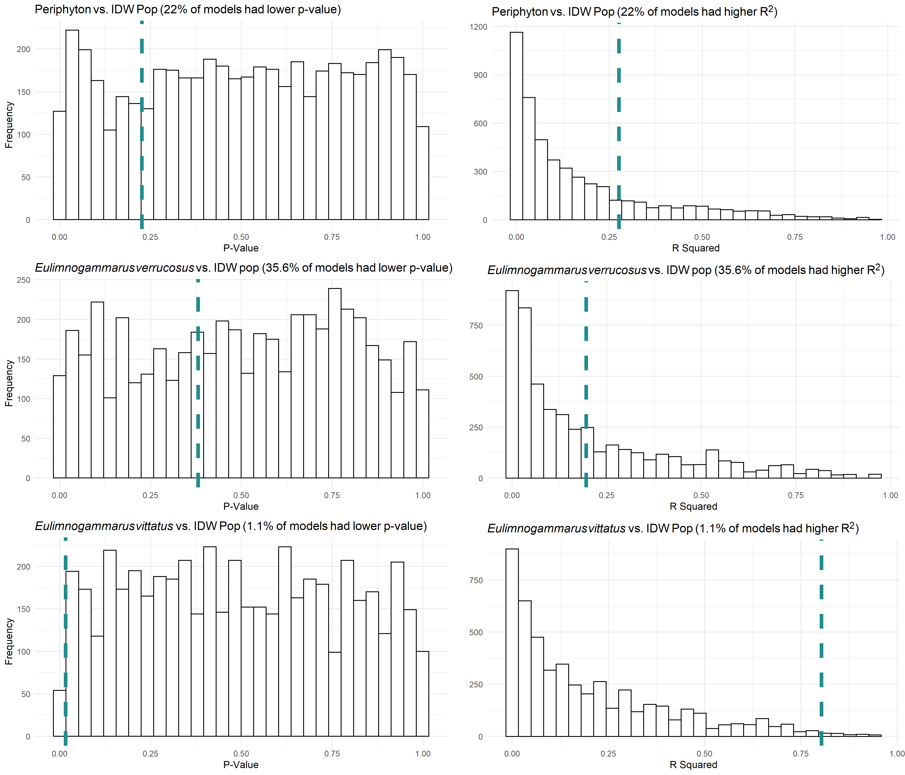

Figure S16: Distributions of p- and R­2 values for filamentous:diatom essential fatty acid ratios in response to IDW population for permuted data. Models were generated from 5,000 data permutations. Histograms represent p- and R2 values estimated from linear models fit with permuted sewage indicator data. The vertical dashed line in each plot represents the p- and R2 value obtained from the linear model fit with non-permuted data. The percent of p- and R2 values occuring respectively below and above values estimated from the non-permuted values are listed in the title of each plot. In the case when a model fit is non-random, the dashed green line should be in the lower 5% tail end for p-values and in the upper 5% for R2 values.

|  |  |
| --- | --- |
| Table S4: Fatty acid groupings used in this analysis | |
| Fatty Acid Group | Fatty acids considered |
| Branched | a-15:0, i-15:0, a-17:0, i-17:0 |
| SAFA | 12:0, 14:0, 15:0, 16:0, 17:0, 18:0, 20:0, 22:0, 24:0 |
| MUFA | 14:1ω5, 15:1ω7, 17:1n7, 16:1ω5, 16:1ω6, 16:1ω7, 16:1ω8, 16:1ω9, 18:1ω7, 18:1ω9, 20:1ω7, 20:1ω9, 22:1ω7, 22:1ω9 |
| SCPUFA | 16:2ω4, 16:2ω6, 16:2ω7, 16:3ω3, 16:3ω4, 16:3ω6, 16:4ω1, 16:4ω3, 18:2ω6, 18:2ω6t, 18:3ω3, 18:3ω6, 18:4ω3, 18:4ω4, 18:5ω3 |
| LCPUFA | 20:2ω5(11), 20:2ω5(13), 20:2ω6, 20:3ω3, 20:3ω6, 20:4ω3, 20:4ω6, 20:5ω3, 22:2ω6, 22:3ω3, 22:4ω3, 22:4ω6, 22:5ω3, 22:5ω6, 22:6ω3 |